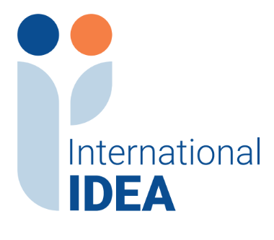

INTERNATIONAL INSTITUTE FOR DEMOCRACY AND ELECTORAL ASSISTANCE RESPONSES TO QUESTIONS
Tender Reference No:2024-02-048

Project Name: Rule of Law and Anti-Corruption Programme (RoLAC) Phase II

Assignment Name: The provision of graphic design, Printing of manuals, books, and promotional materials for the International IDEA offices across Nigeria.

Based on questions received, the information below is provided for clarification regarding the tender referenced above. Please note if new questions are received, they will be added to this document.

- Question: Please kindly clarify us on the price approach, what are the items we are to send prices for?

Response: The Price approach requires prices for items 1 to 79 in line with the respective quantity to be supplied. Under other requirements please provide the transportation costs applicable to supplier 1 or supplier 2 or supplier 3 in line with the location to be supported.

