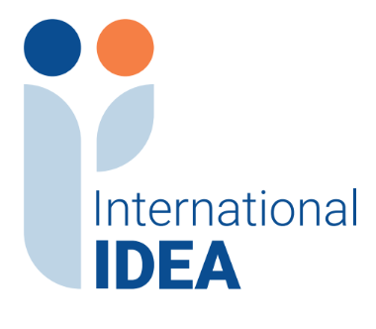

INTERNATIONAL INSTITUTE FOR DEMOCRACY AND ELECTORAL ASSISTANCE RESPONSES TO QUESTIONS
Tender Reference No:2024-01-047

Project Name: Rule of Law and Anti-Corruption Programme (RoLAC) Phase II

Assignment Name: Open call for submission of grant proposals

Based on questions received, the information below is provided for clarification regarding the tender referenced above. Please note if new questions are received, they will be added to this document.

- Question: We write to request for a call for proposal templates as we can't find it in the advertised document

Response: Kindly note that the call for proposal templates are published on the website alongside the Call for proposal.

