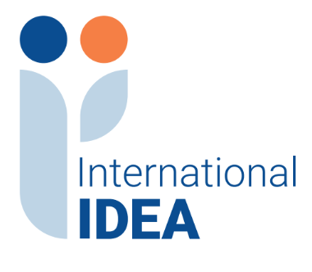

INTERNATIONAL INSTITUTE FOR DEMOCRACY AND ELECTORAL ASSISTANCE

RESPONSE TO QUESTIONS REGARDING TENDER 2025-09-073

Assignment Name: Graphic Design Services (For use across the entire organization)

Based on questions received, the information below is provided for clarification regarding
the tender referenced above. Please note if new questions are received, they will be added to this document.

- Question: Is it possible for two companies to submit a joint application ?

Response: Yes, it is possible for two companies to submit a joint proposal for the services they can jointly provide (as per 1.5 in the Tender Notice, it is anticipated that International IDEA may include Providers that can provide all or only one of the required areas of services tendered for)

- Question: Country eligibility: Could you please confirm whether companies based in Kosovo are eligible to participate in this tender ?

Response: Yes, provided they meet all requirements stated in the tender documents.

- Question: Language requirements: The TOR lists multiple languages used across International IDEA’s publications and communications materials. Could you please clarify whether: International IDEA will provide all final text content in the required languages, and the Provider is not expected to offer translation services as part of its proposal ?

Response: Yes

- Question: Country eligibility: Could you please confirm whether companies based in Canada are eligible to participate in this tender?

Response: Yes, companies that meet all requirements stated in the tender documents are eligible to participate in this tender, regardless of location.

- Question: Should the technical proposal be submitted in a free format, or is there a specific template that needs to be followed ?

Response: There is no specific template for submission of the technical proposal. Kindly refer to Section 2.4 (iii) in the Tender Notice regarding submission of samples of previous work and Section 3 for instructions for submission of proposals.

