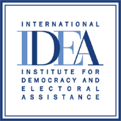

INTERNATIONAL INSTITUTE FOR DEMOCRACY AND ELECTORAL ASSISTANCE

TENDER NOTICE

Tender Reference No: 2021-02-001
Assignment Name: Consultancy Services - IKNOW Politics Network Facilitator
Project Name: IKNOW Politics 2021
Deadline for Submissions: Proposals (CV, Letter of Motivation and declaration on honour form) must be submitted on or before 23:59 (CET), 19 September 2021. Late submissions will not be considered for evaluation.
Address for Submissions: E-mail: tendersubmissions@idea.int
Format for Submissions: Submissions in electronic format by email.
The following text should be put in the subject field of the email: Tender Ref. No. 2021-02-001 – Do not open before 23:59 (CET), 19 September 2021.

Email Address for Clarifications: E-mail: tender@idea.int
Clarifications may be requested via e-mail no later than 12 September 2021 at the above email address. Note a response to a request for clarifications will be issued to all tenderers on our website http://www.idea.int/. Therefore, tenderers are advised to check the website regularly during the process.

Note: There are two different email addresses as outlined above, one to be used for Submission of your final proposal and the second one to be used for clarifications and other related correspondence.
REQUEST FOR PROPOSALS

Section 1 General Information
  - The International Institute for Democracy and Electoral Assistance (International IDEA) is an intergovernmental organization established in 1995, with member states across all continents, which aims to support sustainable democracy world-wide and assist in the development of institutions and the culture of democracy. At the interface between research, fieldwork and the donor community, IDEA provides a forum for dialogue, builds networks of experts, develops training materials and provides strategic advice at international, regional and national level, cooperating with a range of organizations.
1.2 International IDEA supports the International Knowledge Network of Women in Politics (iKNOW Politics), a joint initiative of International IDEA, UN Women, UNDP, and the Inter-Parliamentary Union. It is a global online platform (www.iknowpolitics.org) designed to increase the participation and effectiveness of women in political life by utilizing a technology enabled forum to share best practices on women's political participation, representation, and leadership. Available in Arabic, English, French, and Spanish, the iKNOW Politics website aims to increase the number and effectiveness of women in political life by utilizing a technology enabled forum to provide access to resources, expertise, exchange, and knowledge creation on women's political participation, representation, and leadership. The iKNOW Politics website is visited by more than 200,000 users yearly.
1.3 International IDEA now invites proposals from qualified consultants (individuals) for iKNOW Politics Network Facilitator (home-based). The services include expanding and updating the iKNOW Politics language platforms in English, Spanish and French, and strengthening its online community through website management and social media activities. A detailed description of the assignment is provided in the Terms of Reference attached to this Request for Proposals.
1.4 Tentative timeframe: It is anticipated that the services will commence on 15 October 2021 and they will have to be completed before 31 December 2021. With possibility to be extended for further periods based on performance and availability of funds.
1.5 Estimates input: The work will be undertaken on a full-time consultancy basis (5 working days a week).
1.6 Budget: 5,000 USD/month
Note: The consultant shall be responsible for his or her own tax obligations as per the laws of the respective country.

Section 2 Preparation of the Submission
  - Language: The official language for the CVs, motivation letters, contracts, reports and any other documents in relation to the assignment is English.
  - Required experience: As outlined in the attached Terms of Reference.
  - The Motivation Letter should describe the consultant’s background in website content management, brief description of knowledge of advocacy trends of women in politics and experience in women’s participation, representation and leadership (if any), outline his/her skills and relevant experiences, language skills and level.
2.4 The CV should provide information on the qualification of the consultant, his/her general track record, previous specific experience in similar assignments, and level of language proficiency.
2.5 The full contact details (name, title, email address, telephone number) of three professional references should be provided.
2.6 Declaration of Honour form: Please complete the form and submit together with 2.3 and 2.4.

- Please leave this section blank.

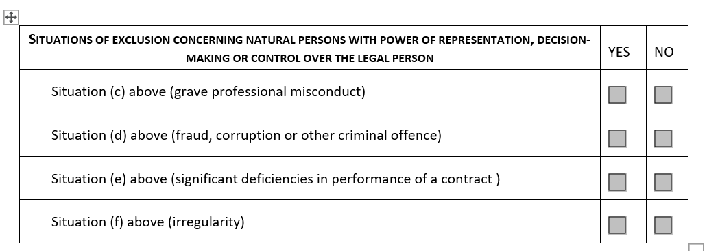

- In the absence of conflict of interest, please mark this section Yes.
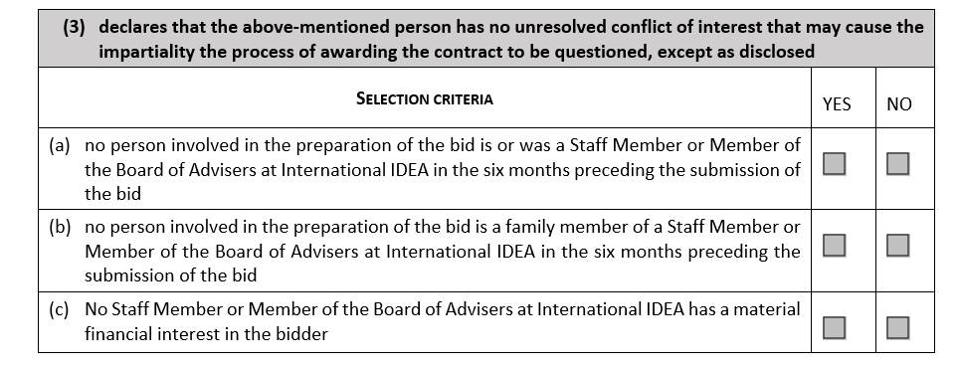

Section 3 Submission of Requirements
  - The required documents should be submitted in electronic format by e-mail. The full details on how to submit proposals is under Tender Notice at the beginning of this document.
  - Submissions must remain valid for at least 60 days following the deadline for their submission stated under the Tender Notice.

Section 4 Evaluation of CVs, Motivation Letter and Interview
4.1 The CVs and Motivation Letters will be evaluated and scored against the following technical criteria with respective corresponding points.
4.2 Technical Evaluation:
Technical Evaluation: general qualifications and skills, specific qualifications relevant to the assignment, including language fluency (50 points).
4.2.1 Demonstrated experience in writing, proofreading, and editing in English, Spanish and French, particularly for an online platform (max 10 points) (5 or more relevant years of experience: 10 points; 3-4 years experience: 7 points; 1-2 years experience: 4 points; less than 1 year: 2 points; no experience: disqualification)
4.2.2 Demonstrated experience in digital communications and social media content creation (max 10 points) (5 or more relevant years of experience: 10 points; 3-4 years experience: 7 points; 1-2 years experience: 4 points; less than 1 year: 2 points; no experience: disqualification)
4.2.3 Demonstrated experience in the use of website content management systems, such as Drupal (max 10 points) (5 or more relevant years of experience: 10 points; 3-4 years experience: 7 points; 1-2 years experience: 4 points; less than 1 year: 2 points; no experience: 0 point)
4.2.4 Demonstrated experience in designing knowledge management products and in event management (e.g., newsletters, online discussions, webinars, and live social media events) (max 7 points) (3 or more relevant years of experience: 7 points; 1-2 years experience: 4 points; less than 1 year: 2 points; no experience: 0 point)
4.2.5 Demonstrated substantive knowledge of issues on gender equality and political participation (max 5 points) (3 or more relevant years of experience: 5 points; 1-2 years experience: 3 points; less than 1 year: 1 point; no experience: 0 point)
4.2.6 Demonstrated experience in graphic design and video production and editing is an advantage (max 5 points) (3 or more relevant years of experience: 5 points; 1-2 years experience: 3 points; less than 1 year: 1 point; no experience: 0 point)
4.2.7 Proven knowledge in Search Engine Optimization (SEO) is an advantage (3 points) (3 or more relevant years of experience: 3 points; 1-2 years experience: 2 point; less than 1 year: 1 point; no experience: 0 point)
Please note that the total technical score is 50 pts. The minimum passing score is 35 pts.
Following the evaluation related to points 4.2.1 to 4.2.7 above, International IDEA will shortlist the consultants who reached 35 points for interviews. Proposals with zero experience in 4.2.1 and 4.2.2 are disqualified.
4.3 Interview:
- Ability to answer a question and converse in Spanish. (max 10 points) (excellent: 10 points; very good: 7 points; good: 5 points; average: 3 points; poor: 0 point)
- Ability to present one self and answer questions on education and related work experiences in English. (max 10 points) (excellent: 10 points; very good: 7 points; good: 5 points; average: 3 points; poor: 0 point)
- Ability to answer a question on women’s political participation and representation in English. (max 10 points) (excellent: 10 points; very good: 7 points; good: 5 points; average: 3 points; poor: 0 point)
- Ability to answer a question on competency/practical case in English. (max 10 points) (excellent: 10 points; very good: 7 points; good: 5 points; average: 3 points; poor: 0 point)
- Ability to answer a question and converse in French. (max 10 points) (excellent: 10 points; very good: 7 points; good: 5 points; average: 3 points; poor: 0 point)
Please note that the total interview score is 50 pts. A written assessment may be requested if needed as a follow-up to the interview.
The maximum final score is 100 points.
4.4 At the end of the evaluation process 4.2 to 4.3, the consultant ranked highest will be invited to negotiate the contract. If negotiations are successful, the selected consultant will be awarded the contract. Should the negotiations fail; the second ranked consultant will be invited to negotiations.
  - International IDEA reserves the right during the negotiation stage to vary at the time of award of contract, the quantity of services, the time period, or scope of work by up to a maximum of twenty-five per cent (25%) of the original TOR. This negotiation will not permit any changes to unit fee rates or other terms and conditions outlined in the submission.
  - International IDEA reserves the right to directly award a follow up contract to the consultant selected to carry out potential future work related to this initial assignment. This will depend on satisfactory delivery of the assignment.

Section 5 Final Considerations
5.1. International IDEA will not be bound to select any of the proposals.
  - The following documents are enclosed with this Request for Proposals:
- Terms of Reference
- General Terms and Conditions
- Declaration on honour
  - Further information on International IDEA may be found on our website http://www.idea.int/.
  - Both the successful and unsuccessful bidders will be notified in writing following the completion of the evaluation and contract award process.

