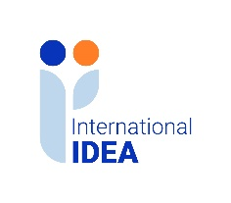

INTERNATIONAL INSTITUTE FOR DEMOCRACY AND ELECTORAL ASSISTANCE
OPEN CALL FOR SUBMISSION OF GRANT PROPOSALS FOR THE RULE OF LAW AND ANTI-CORRUPTION (ROLAC II) PROGRAMME IN NIGERIA
Tender Reference No: 2024-01-047

Clarification Questions and Answers

A question and answer (Q&A) session was hosted by International IDEA on 19 March 2024 at 10:00 am Nigerian time.

Click here to listen to the audio recording of the question and answer (Q&A) session.

