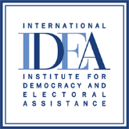

INTERNATIONAL INSTITUTE FOR DEMOCRACY AND ELECTORAL ASSISTANCE

TENDER NOTICE
Tender Reference No: 2021-06-006
Assignment Name: Local Trainers and Facilitators for the Peer-to-Peer sessions, Capacity Building Sessions and Working Sessions

Project Name: A49-Supporting the application of Article 49 and proportionality in Tunisia

Deadline for Submissions: Proposals must be submitted on or before 23:59 (CET), 10/September/2021. Late submissions will not be considered for evaluation.

Address for Submissions: E-mail: tendersubmissions@idea.int

Format for Submissions: Technical proposals must be submitted by email and in one file.
The following text should be put in the subject field of the email:
Tender No. 2021-06-006 Technical Proposals – Do not open before 23:59 (CET), 10/September/2021.

Email Address for Clarifications: E-mail: tender@idea.int
Clarifications may be requested via e-mail no later than 7 days prior to the submission deadline at the above email address. Note a response to a request for clarifications will be issued to all tenderers on our website http://www.idea.int/. Therefore, tenderers are advised to check the website regularly during the process.

Note: there are two different email addresses as outlined above, one to be used for Submission of your final proposal and the second one to be used for clarifications and other related correspondence.
Please submit your proposal to the correct email address: tendersubmissions@idea.int
REQUEST FOR PROPOSALS
Section 1 General Information
  - The International Institute for Democracy and Electoral Assistance (International IDEA) is an intergovernmental organization established in 1995, with member states across all continents, which aims to support sustainable democracy world-wide and assist in the development of institutions and the culture of democracy. At the interface between research, fieldwork and the donor community, IDEA provides a forum for dialogue, builds networks of experts, develops training materials and provides strategic advice at international, regional and national level, cooperating with a range of organizations.
  - International IDEA now invites proposals from qualified individual consultants for the facilitation of the project activities. The services include training and facilitation of the Peer-to-Peer sessions, Capacity Building Sessions and Working Sessions related to Article 49 of the Constitution and the principle of proportionality in order to support the application of Article 49 and proportionality in Tunisia and achieve a better understanding of the limitation clause. A detailed description of the assignment is provided in the Terms of Reference attached to this Request for Proposals.
  - Tentative timeframe: It is anticipated that the services will commence in October 2021 and they will have to be completed before 31/05/2023. Extension of the timeframe is subject to project’s renewal.

Section 2 Preparation of Proposals
Essential Requirements
  - Language: The official language for the proposal, reports and any other documents in relation to the assignment is English, French or Arabic. However, the official language for the contract is English.
  - Estimated input:
For the Peer-to-Peer sessions and Working Sessions, the estimated no. of days is two (2) to complete the assignment.
For the Capacity Building sessions, the estimated no. of days is three (3) to complete the requirements.
  - Required experience: See attached TOR
  - The CV/proposal should provide the following information:
- Qualifications: Have an advanced degree in law, public administration, human rights Law, political science, or related field;
- Relevant experience: Have a relevant experience in public law or in a field related to human rights or constitutionalism.
- Evidence of experience on other similar assignments: Previous experience on Article 49 of the Tunisian Constitution and the principle of proportionality will be considered as an advantage.
- Be fluent in Arabic, knowledge of French and English would be considered an asset.

  - A completed and signed Declaration of Honour form:
- See attached Annex D2.1: Please declare Yes or No as provided
- Please leave this section blank if you are natural person (not legal person/firm/org.)

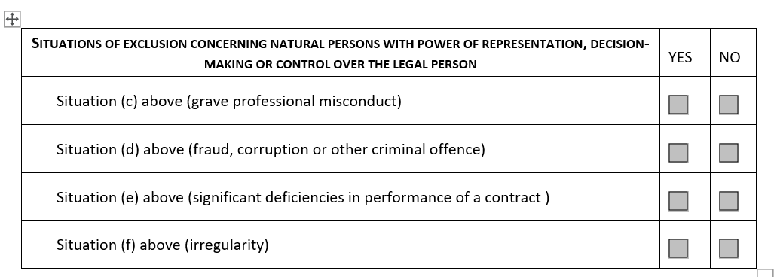

- Section 3, in the absence of conflict of interest, please mark this section “Yes”

Please note:
- Submit the 2.4 i-iv in separate documents with label i, ii, iii and iv under your technical submission.
- Submit the 2.5 Declaration of Honour form in a separate file.
- Incomplete submission of 2.4 will not be considered for evaluation.

No Financial Proposal
  - The price for this request for proposal is fixed to Three Hundred Euros (EUR 300) per working day (unit rate).
  - The bidder/individual consultant shall be responsible for his or her own tax obligations as per the laws of the respective country.

Section 3 Submission of Proposals
  - Proposals should be submitted in electronic format by e-mail. Technical proposal and annexes must be submitted in separate files and marked accordingly. The full details on how to submit proposals is under Tender Notice at the beginning of this document.
  - Proposals must remain valid for at least 60 days following the deadline for their submission stated under the Tender Notice. During this period, the individual consultants are expected to be available for the assignment.

Section 4 Evaluation of Proposals
Technical Evaluation:
4.1 The proposals will be evaluated and scored against the following technical criteria with respective corresponding weights:
- General qualifications and skills (maximum score 20);
- Have an advanced degree in law, public administration, human rights Law, political science, or related field (10)
- Master degree: (6)
- PhD: (10)
- Be fluent in Arabic, knowledge of French and/or English would be considered an asset (10)
- Fluent in Arabic only: (5)
- Fluent in Arabic and another language (10).
- Specific qualifications relevant to the assignment (maximum score 30);
- Relevant experience: Have a relevant experience in public law or in a field related to human rights or constitutionalism.
- Less than 15 years: (15)
- 15 years or more (30)
- Experience working with International Organisations (maximum score 20);
- 1 to 3 years: (05)
- 4 to 6 years: (10)
- 7 to 10 years: (15)
- More than 10 years: (20)
- Specific professional experience in the field of the assignment (maximum score 30).
- Previous experience on Article 49 of the Tunisian Constitution and the principle of proportionality (writing articles, books, training in proportionality etc.)
- modest experience: (10)
- extensive experience: (20)
- proven experience: (30)
Please note: The maximum technical score (T) is 100 points. The minimum passing score is 50 points.
No Financial Evaluation

Section 5 Final Considerations
  - International IDEA will not be bound to select any of the proposals.
  - This request for proposals is to establish a Framework Contract for an initial period of two (2) years subject to extension of three (3) years upon project’s renewal. The Engagement of the selected individual consultant for a specific assignment will be by means of Service Order during the coverage of the Framework Contract.
  - This tender aim to constitute a pool of individual consultants and the number of Framework Contract will be determined along the project timeline.
  - The following documents are enclosed with this Request for Proposals:
Terms of Reference
Declaration of Honour Form
General Terms and Conditions
  - Further information on International IDEA may be found on our website http://www.idea.int/
  - We would appreciate your informing us by e-mail (contact details above):
- Upon your receipt of this Request for Proposals, whether or not you intend to submit a proposal;
  - Both the successful and unsuccessful bidders will be notified in writing following the completion of the evaluation and contract award process.
Complaints regarding any aspect of the tender process should be addressed in writing to both the Internal Auditor and the Executive Director at International IDEA. The address is tender.complaints@idea.int

