ADDENDUM: TENDER 258-20/37

Assignment Name: Engagement of Senior Expert Consultants – Electoral Processes Programme, International IDEA

Addendum No. 1

This Addendum No. 01 is issued to provide additional information provided in the Tender: Engagement of Senior Expert Consultants – Electoral Processes Programme, International IDEA issued last 29, January 2021.
EOI Notice:
- Completed Declaration of Honour Form (Annex D2.1) (Please declare Yes or No as provided)

Additional instruction:

- Please leave this section blank if you are natural person (not legal person/firm/org.)

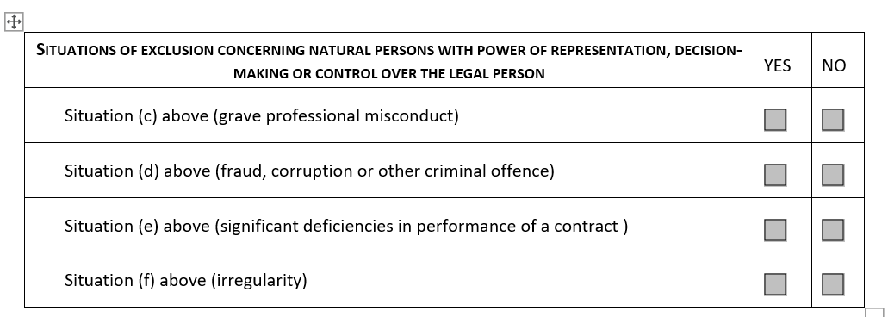

- In the absence of conflict of interest, please mark this section Yes.
