Tender Test for Light Copyediting

Regulating the Business of Election Campaigns

Financial transparency in the influence ecosystem in the United Kingdom

Kate Dommett
Sam Power
Amber Macintyre
Andrew Barclay

Acknowledgements

International IDEA would like to thank the research team (Kate Dommett, Sam Power, Amber Macintyre, Andrew Barclay) for drafting the report. The report and the production process were led, coordinated and supervised by the Money in Politics team, within the Electoral Processes programme, especially by Yukihiko Hamada and Khushbu Agrawal. We would also like to express our gratitude to Massimo Tommasoli, Therese Pearce-Laanela and Sead Alihodžić for reviewing the draft of the report and providing their valuable comments and feedback. Thanks also to Sarah Chatwin from Accuracy Matters, Lisa Hagman and Tendai Chinamora-Jönsson for their support in various editorial and administrative tasks.

The research team carried out this study as part of their larger project, ‘Data-driven campaigns: intended and unintended consequences for democracy (DATADRIVEN)’. They would like to acknowledge that the project is financially supported by the NORFACE Joint Research Programme on Democratic Governance in a Turbulent Age and co-funded by [AEI, AKA, ANR, ARRS, DFF, DFG, ESRC, FNR, FWF, FWO, IRC, NCN, NWO, RCN, SNSF and VR], and the European Commission through Horizon 2020 under grant agreement No. 822166. This research was also made possible thanks to funding Tactical Tech has received for its own projects from the Swedish Postcode Foundation and Swedish International Development Agency.

Executive Summary

Political parties operating in modern democracies rely on working with private companies and external organizations to campaign effectively. From the expertise of marketing and campaign professionals to the production of advertising content and overcoming the logistical challenges of running a campaign, there are a wide range of services which parties either need or prefer to source from suppliers.

Despite their importance, relatively little is known about these organizations and the relationship that they have with campaigns. This is especially notable when it comes to transparency, the proliferation of companies which specialise in data and digital technology, and the suggestion that some of these companies have engaged in potentially duplicitous practices (most notably in the case of Cambridge Analytica).

This report addresses this deficit by looking in-depth at the United Kingdom, whose electoral transparency regime is regarded as world leading. The report uses the UK Electoral Commission's database of spending returns for the 2019 General Election to understand what suppliers and services parties spent their money on. 13,202 invoices were systematically analysed to investigate the kinds of companies that parties engage with and the specific services that they are providing.

In terms of the services which the parties’ resourced, it was found that:
- Just under 50 per cent of total general election spend (GBP 21.5 million) was used on the production of campaign materials and, primarily, the printing and distribution of campaign literature.
- Over 50 per cent of all advertising spend was on social media ads.
- The vast majority (over 95 per cent) of companies only worked with a single party, but those companies that supplied multiple parties commanded the highest fees.

The research also highlighted several transparency deficits:
- Over 40 per cent of the suppliers in the database submitted at least one invoice in which the service provided could not be discerned.
- Approximately 14 per cent of total expenditure (over GBP 6.6 million) could not be categorized as it came in the form of unclear invoices.
- Despite being effectively world leading, the Electoral Commission’s existing classification framework is too broad to capture the diversity of techniques used in modern political campaigns.

Drawing on this research and findings, this report considers how existing transparency disclosure requirements could be improved to aid understanding of external suppliers and reflects on the suitability of existing declaration categories. Recommendations have been provided for the UK Electoral Commission, which can serve as lessons learnt for electoral management bodies (EMBs) outside of the UK. Additionally, recommendations have been provided for political parties and civil society organizations (CSOs) working in developed and developing democracies alike.

Introduction
Election campaigns are central to modern democracy. At these moments, political parties and campaigners devote significant energy to maximizing support, and citizens exercise choice over who holds power. Despite the importance of elections, there are many aspects of current practice that little is known about. This report focuses on the role played by companies and other external organizations providing services to parties in election campaigns. Although they have long been a component of the electoral landscape, suppliers of election services have recently become a focus of interest as evidence of potentially duplicitous practice has arisen. Highlighted by the case of Cambridge Analytica, questions have emerged about who is active within election campaigns and what services they provide. In particular, these questions have focused on the support external companies and external organizations give political parties in relation to the use of digital technology (Dommett et al. 2021), with evidence that at least 500 companies internationally are offering data services to parties (Macintyre 2018, 2021). In spite of this interest, to date there is little understanding of these organizations and minimal evidence on which to judge whether the services they provide are problematic.

This research set out to understand more about the organizations that work with parties in election campaigns specifically in the UK context. The analysis offers new empirical insight into the role played by suppliers, detailing the work conducted by these organizations and the money expended on them. Exploring available information within financial transparency disclosures made to the UK Electoral Commission, the research also aims to draw lessons for policymakers, regulators, and CSOs to specifically promote increased transparency. Recommendations are directly made for the UK Electoral Commission, which can also be applicable for EMBs and oversight agencies outside of the UK.

The principle of transparency is well established in guiding the regulation of elections. Indeed, while a system will never be perfectly transparent, it is generally agreed that transparency itself is the ‘most important requirement’ in attempting to regulate political financing (Nassmacher 2003: 139). Most countries around the world have some kind of disclosure regime: 62.2 per cent of countries require financial reports from parties/candidates to be made available to the public, in Europe this figure jumps to 95.5 per cent (International IDEA n.d.). The level of transparency, however, varies. In some countries, reports are made public (sometimes in near-real time), but in others they are difficult to access. Comparatively, the UK is a little slower to disclose election returns than institutionally similar countries (CSPL 2021: 81). In the UK, the biggest spenders at elections have six months to supply returns to the Electoral Commission, which compares with monthly disclosure requirements during election periods in the United States, 56 days in Ireland, 10 weeks in France, and 70–90 days in New Zealand. Despite the length of time before spending must be reported, the UK Electoral Commission’s ‘political finance database’ is ‘effectively world leading at this point’ because of the insights it contains (Power 2020a: 132). By examining the effectiveness of the UK’s financial database for providing transparency on the role of private companies in elections, this report will draw out some lessons learnt for what works and what doesn’t, which could also be applicable to other international political finance oversight bodies

While transparency is an established principle in the UK, electoral regulators have argued that the existing system of disclosure is not fit for purpose. Particularly around the rise in digital campaigning, the UK Electoral Commission, for example, argued in 2015 that expenditure reporting categories needed to be reviewed ‘to ensure that they remain proportionate and relevant to future trends in campaigning’ (Electoral Commission 2016a: 8). More recently, the Electoral Commission (2018: 12) also recommended that policymakers should ‘make campaigners sub-divide their spending returns into different types of spending. These categories should give more information about the money spent on digital campaigns´. Similarly, in the USA—another example of a reporting system that is used to demonstrate best practice in transparency—there have been repeated calls for improvements in their database. Experts have suggested that a ‘more effective disclosure regime would allow voters to use the FEC’s [Federal Election Commission] website to explore the vectors of political influence’ (Shaw, 2018: 169). In the context of debates around election suppliers, this report considers how existing transparency disclosure requirements could be improved to aid understanding of these organizations. It also reflects on the suitability of existing declaration categories within transparency returns.

Chapter 1

Overview of the current political landscape in the UK
UK national politics is dominated by two political parties: the Conservatives and Labour, who have largely alternated as the single party of government in the post-war period. While the UK system is often explained as exhibiting ‘two-party politics’, Webb and Bale (2021: 15) instead describe it as exhibiting ‘moderate multipartyism’. This term captures the way in which the first-past-the-post voting system helps sustain the dominance of the two largest parties in terms of seats in the House of Commons, while also recognizing the relatively strong position of a wider range of smaller parties in terms of vote share or localized electoral success.

In total, 33 parties gained more than 1,500 votes each at the 2019 General Election (see Uberoi et al. 2020). Of these, 10 parties hold seats in the Westminster Parliament, although five of them received fewer votes than the Brexit Party which—despite gaining over 2 per cent of the national vote share—was left empty-handed in terms of representation in the national parliament (see Table 1). In addition, ethno-regionalist parties, such as Plaid Cymru (Wales), the Scottish National Party (SNP; Scotland), and the Democratic Unionist Party (DUP) and Sinn Féin (both Northern Ireland), all had electoral success and gained seats in the Westminster Parliament.

Table 1: Outcome and number of candidates at the 2019 UK General Election by party
Party | Candidates | Votes | Vote share (%) | Seats in the House of Commons
Conservatives | 635 | 13,966,454 | 43.63 | 365
Labour | 631 | 10,269,051 | 32.08 | 202
Liberal Democrats | 611 | 3,696,419 | 11.55 | 11
Scottish National Party | 59 | 1,242,380 | 3.88 | 48
Green parties | 497 | 865,715 | 2.70 | 1
Brexit Party | 275 | 644,257 | 2.01 | 0
Democratic Unionist Party | 17 | 244,128 | 0.76 | 8
Sinn Féin | 15 | 181,853 | 0.57 | 7
Plaid Cymru | 36 | 153,265 | 0.48 | 4
Alliance Party | 18 | 134,115 | 0.42 | 1
Social Democratic and Labour Party | 15 | 118,737 | 0.37 | 2
Source: Uberoi E. et al., General Election 2019: Results and Analysis, Briefing Paper No. CBP 8749 (London: House of Commons Library, 2020), <https://researchbriefings.files.parliament.uk/documents/CBP-8749/CBP-8749.pdf>, accessed 14 March 2022, pp.8–9.

In the UK, elections are regulated by the Electoral Commission, which was established in the year 2000, after the passage of the Political Parties, Elections and Referendums Act 2000 (PPERA). The Commission has the primary responsibility for investigating and sanctioning breaches of PPERA—with powers such as issuing fines (ranging from GBP 200 to GBP 20,000), ‘compliance and restoration notices’ (requesting particular action be taken to ensure compliance) and ‘stop notices’ (requesting a particular action is stopped). Criminal sanctions are generally a matter for the police (Electoral Commission 2021) and courts. Investigations are first undertaken by the police (who can receive guidance from the Electoral Commission) before findings are presented to the Crown Prosecution Service (CPS). The CPS then applies a ‘two-stage test’ to establish, first, whether the evidence provides a realistic prospect of conviction, and second, whether prosecution is in the public interest.

Many political finance rules in the UK have been in place for over 100 years. Indeed, certain legal principles (such as a cap on spending at the constituency level) were initially set out in the Corrupt and Illegal Practices (Prevention) Act 1883. That said, there are two primary pieces of legislation that guide British political finance—the Representation of the People Act 1983 (RPA) and PPERA. In the very simplest terms, PPERA regulates party (i.e. national) spending and the RPA covers candidate (i.e. local) spending. This leads to a piecemeal, fragmented and often confusing landscape of electoral law. It has been described as resembling ‘a Jane Austen-style intricate dance, where all sorts of daring and dicey moves are permissible, provided you know where to step and when, and how not to upset the crowds’ (Ball 2020). For its purposes, this report focuses on the major principles of the regulatory framework, as laid out in PPERA and the RPA. The analysis looks at spending declared by national parties as opposed to local candidate spending (i.e., as regulated mostly under PPERA).

What are the rules on spending in the UK?
There is tightly controlled regulation of spending within the UK’s existing electoral law. In general elections, there are limits on spending at both the party and candidate levels. Party spending is calculated as GBP 30,000 for each seat a party contests, which—given that there are currently 650 constituencies—gives a spending limit of GBP 19.5 million. For candidates, there are two spending limits—one for the short campaign, and one for the long campaign—and these vary given the number of electors in each constituency. In terms of the campaign period for candidates, the short campaign officially begins when parliament dissolves in advance of an election, while the long campaign relates to the (approximately) three-month period preceding that point. For parties (i.e. national spending), there is usually a regulated period of 365 days, ending on the day of the election (at the 2019 General Election, the regulated period began on 13 December 2018).

Spending on elections by political parties, candidates and third parties must be reported to the Electoral Commission. For parties, this must include details such as receipts and invoices for any (campaign) spend that occurs over GBP 200 within the regulated period (i.e. up to 365 days before the election). These invoices are made available on the Electoral Commission’s political finance database (Electoral Commission 2022) and can be viewed as pdf files. When the spend is recorded, it is done so under one of 10 categories that provide a broad overview of the different kinds of activities on which money is spent:
- unsolicited material to electors;
- market research/canvassing;
- rallies and other events;
- transport;
- media;
- advertising;
- overheads and general administration;
- manifesto or referendum material;
- campaign broadcasts (i.e. election broadcasts on television); and
- balancing items.

These categories are one of the main areas of investigation of this report.

Chapter 2

What does the UK Electoral Commission’s political finance database reveal about spending at the 2019 General Election?
The political finance database provides the details of the spending declared by every registered political party at every general election since 2001 (the transparency regime was significantly boosted after the implementation of PPERA before the 2001 General Election). As Figure 1 shows, spending is dominated by the two main parties (the Conservatives and Labour)—but particularly the Conservative Party; only in 2005 did Labour outspend the Conservatives. However, in recent years, the Liberal Democrats, as the main challenger party, have begun to compete financially. 2019 was the first year that the Liberal Democrats (at GBP 14.4 million) spent more than the Labour Party (GBP 12 million), but both were still behind the Conservatives (GBP 16.5 million).

Figure 1: Total UK General Election spending by party, 2001–2019
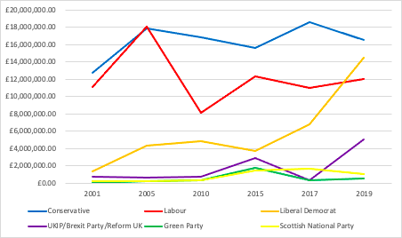
Source: Compilation by authors with information from the Political Finance Database of the UK Electoral Commission
It is also possible to break down the kinds of spending that are prevalent. Figure 2 shows that, in recent years, ‘unsolicited material to electors’ has dominated spending activity in general elections. In 2019, around GBP 20.5 million of spending was categorized under this heading, which amounts to well over a third of the total spend (which stood at around GBP 50 million). Advertising (GBP 14 million) and market research/canvassing (GBP 6.4 million) account for the other primary forms of spending. Together, these three categories contribute over 80 per cent, or GBP 40.9 million, of total spending in the 2019 General Election.

Figure 2: Total UK General Election spending by all parties by category, 2001–2019
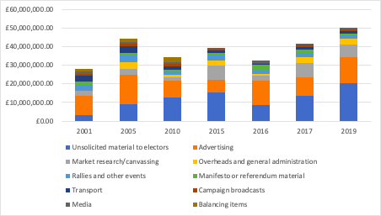
Source: Compilation by authors with information from the Political Finance Database of the UK Electoral Commission

Electoral Commission data and election campaign suppliers
Looking at the spending returns in more detail, it is possible to gather some initial information about the suppliers working in election campaigns. Electoral Commission returns show a total of 1,006 separate suppliers working for (at least) one of the political parties in the 2019 General Election. The vast majority—959—of these suppliers work with single parties, but a small number—47 (representing less than 5 per cent of suppliers)—work with multiple parties.

As shown in Figure 3, Facebook is by far the most prolific supplier, working with 11 political parties to provide either ‘advertising’, ‘overheads and general administration’, ‘unsolicited material to electors’ or ‘media’, according to the Electoral Commission categories. The next are JPI Media and Reach Printing Services Ltd, who work with six parties each. Most of the remaining suppliers serving multiple parties (34) work with just two different parties.

Figure 3: Suppliers working for multiple parties in the UK General Election 2019, by number of parties
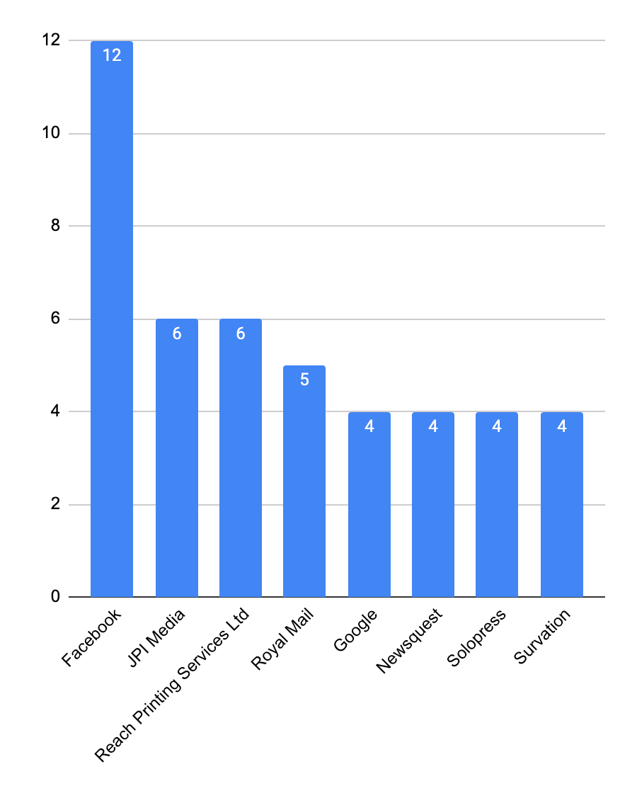
Source: Authors´ analysis of invoices returned to the Electoral Commission for the 2019 General Election.

Looking at the amounts these suppliers are charging parties, it is clear that they differ markedly (see Table 2). Facebook, for example, is one of the top four suppliers paid by the parties featured in Table 2, but while the Labour Party spent nearly GBP 2.4 million with Facebook, the Greens spent just over GBP 93,000. Whilst some variation in spending could reflect parties’ own choices about where to concentrate resource, the vastly different amounts spent by parties (Figure 1), suggests that parties do not have equal resource to spend on external suppliers. This also reflects the institutional reality that some parties are simply bigger (and richer) than others.

Table 2 also reveals that the five parties featured use some of the same suppliers. The panes shaded blue indicate suppliers who work with more than one party, demonstrating that many of the suppliers commanding the highest spend work with multiple parties (12/34 of the multi-party suppliers identified in the database feature in Table 2). These suppliers appear to dominate the market and exert a monopoly on particular aspects of the electoral marketplace. Whilst such dynamics are not inherently problematic, they suggest a need to monitor the activities of monopolistic actors to ensure equal access is available to all campaigners.

Table 2: Suppliers commanding the highest spend in the UK General Election 2019, by party
 | Conservatives |  | Labour |  | Liberal Democrats |  | Green Party |  | Reform UK
1 | Whistl | GBP 2,436,522 | Facebook | GBP 2,407,441 | Postal Choices Ltd t/a Onepost | GBP 3,028,321 | Facebook | GBP 93,499 | Facebook | GBP 588,504
2 | CTF Partners Limited | GBP 1,689,000 | Sterling | GBP 1,319,227 | Paragon Customer Communications Ltd | GBP 2,220,759 | Reform Act | GBP 38,855 | COR Research | GBP 477,160
3 | Paragon Customer Communications Ltd | GBP 1,339,540 | Whistl | GBP 1,248,431 | Royal Mail Group | GBP 1,366,606 | Acanthus Press Ltd | GBP 19,350 | YOU Agency Ltd | GBP 396,862
4 | Facebook | GBP 1,014,277 | Experian | GBP 1,087,076 | Facebook | GBP 1,317,155 | Brown Knight & Truscott | GBP 19,320 | MSI MEDIA LIMITED | GBP 333,525
5 | Google Ireland Ltd | GBP 879,091 | Google Ireland Ltd | GBP 754,618 | MBM Print SCS Ltd | GBP 667,260 | Leaflet Frog | GBP 17,745 | DG3 Group Holdings Ltd | GBP 309,865
6 | Hanbury | GBP 708,000 | DSPolitical International | GBP 575,000 | Park Communications Ltd | GBP 545,837 | Lisbon | GBP 12,239 | Cedar Press Ltd | GBP 238,286
7 | PM Solutions | GBP 535,670 | tmwi Limited | GBP 477,285 | Whittington Moor Printing Works Ltd | GBP 466,309 | AGA Print Ltd t/a Solopress | GBP 8,028 | Triplep Marketing Ltd | GBP 200,758
8 | Topham | GBP 458,688 | McLays | GBP 346,463 | Stannp Ltd | GBP 360,876 | Postworks | GBP 7,500 | Street Runners Ltd | GBP 195,120
9 | Crimson Tangerine | GBP 418,400 | Potts Print | GBP 314,713 | Mortons Media Group Ltd | GBP 296,7³⁴ | 1st Choice Facilities Services Ltd | GBP 7,500 | Bakergoodchild | GBP 192,714
10 | Blue Telecoms | GBP 399,866 | Barefoot Live | GBP 203,357 | NGP Van Inc | GBP 218,374 | Newsquest (London) Ltd | GBP 7,335 | Secura HQ Ltd | GBP 189,224
Source: Authors´ analysis of invoices returned to the Electoral Commission for the 2019 General Election.

Notes: (1) All figures have been rounded up or down to the nearest pound.
(2) If a pane is shaded blue but the supplier does not appear twice in Table 2, this shows where a supplier is working with another party that is either not listed in this table, or is listed but the supplier does not feature as one of the top 10 by spend by that party.

While providing some information about the nature of the election supplier industry, many questions remain unanswered. It is not clear, for example, what exactly these suppliers are doing for parties in practice, and whether the Electoral Commission’s categories provide an accurate account of campaign activity.

For this reason, the research team analysed 13,202 invoices returned to the Electoral Commission (these invoices covered all Electoral Commission categories except transport, which was excluded from the analysis). Applying a custom coding process (outlined in the Appendix on Methodology), the research team generated new insight, first, into the quality of existing transparency declarations, and second, into the suitability of existing declaration categories.

Before turning to introduce this analysis, it is useful at this point to reflect on the utility of the Electoral Commission database when investigating suppliers. The Commission’s database, while far from perfect, represents best practice in disclosure and can serve as a good base to be adopted and implemented beyond the UK. However, it can still be improved. At present, the Electoral Commission allows campaigner to manually enter the name of each supplier, and as a result there can be different iterations of the same company name. For example, in the 2019 spending returns JPI Media appears as ‘JPI MEDIA’, ‘JPI Media Ltd’, ‘JPI Media Publishing’, ‘JPI Media Publishing Limited’ and ‘JPIMedia Publishing Ltd’. The research team coded these entries as referring to the same company, verifying this by checking that the letterhead for invoices from each of these companies was consistent. To aid analysis, however, it would be beneficial to ensure systematic reporting procedures by establishing unified identities for suppliers. As with other standardized systems, where it is possible to select, for example, an address or a job title from a dropdown list of options, verified ‘supplier’ options with details of the address, contact and web presence of each supplier could be created. Such a system would not only help to ensure consistent reporting, but could be linked to additional data about suppliers, such as their Companies House entry or website, to aid future research and transparency efforts. Using mechanisms designed under, for example, the My Little Crony database (Hill 2021), the suppliers might also then be connected to any other number of businesses registered by them under Companies House.

Considerations for the UK Electoral Commission:
- Implement a system of publicly accessible categorized spending reports and invoices, ideally standardized across countries to enable comparability.
- Create standardized records of ‘suppliers’ in election campaigns to ensure consistency in reporting and to aid future research.
- Extend existing transparency by linking supplier information to other sources of publicly available information (such as, in the UK, Companies House records) and supplier websites to facilitate future research.

Investigators, election monitors and other CSOs that support transparency and accountability during elections can, and should, still rely on the existing transparency processes hosted by their local and national EMBs. While looking at digital elections especially, there is so much constantly changing in the industry—and in the understanding of technology seen between political parties, the technology companies and the EMBs—that any reports and invoices are a good starting point. CSOs can, in turn, use the introductory information in this report to assess what information might be missing. CSOs that campaign to promote increased transparency and accountability may advise EMBs to make available the information and formats that are used within the UK’s electoral database and include the advice in this report as a starting point for requesting transparency from their national EMBs.

Considerations for CSOs include:
- Utilize existing transparency returns made available by government and EMBs to scrutinize electoral practices, highlight concerns and make complaints to EMBs.
- When campaigning to promote increased transparency, catalogue the types of work that suppliers perform by studying invoices and, where existing declaration categories are seen to inadequately capture campaign activity, CSOs should press for new categories to be adopted as standard.
- Monitor the practices of monopoly suppliers to ensure that pricing and access are not altered in ways that prevent the use of services and raise concerns with EMBs.

Section summary

- Less than 5 per cent of suppliers work for more than one party, but these are disproportionately more likely to be those that command the highest fees from the parties they serve.
- A small number of suppliers appear to dominate the market when it comes to the service they provide. This is particularly true of Facebook, which features among the highest-spend suppliers for each of the main parties (and were hired by 12 separate parties for the 2019 General Election).

Insights from Electoral Commission invoices
The analysis by the research team demonstrates several areas for improvement in the existing system of invoice declaration. For example, under Electoral Commission rules, invoices need to be provided for all spending over GBP 200, and yet the research team found multiple instances in which invoices were missing, wrong or unclear.

At the most practical level, invoices submitted by 40.6 per cent—or just over two in five—of suppliers were coded in some way as ‘completely unclear’ because for at least one invoice it was not possible to determine what service had been provided. This could occur for several reasons (see Figure 4). In most instances, coloured in (two shades of) blue in Figure 4, invoices were not provided. There were 219 cases where spending was reported by Conservative Party Constituency Associations (CAs) (e.g. Reading West CA), but no invoices were provided, even if the spend was over GBP 200. In addition, there were 50 other suppliers (who were not Conservative Party CAs) where spending was over GBP 200, but an invoice was not provided). This might happen for all the invoices provided by a particular supplier, or simply for one invoice of many which contained more detail (in which instance, the research team coded the available information).

There were 77 suppliers that provided multiple invoices for their work, but at least one (but sometimes all) submission was blank (and hence could not be coded). There were also 45 suppliers where at least one item of declared spending was under GBP 200, meaning that an invoice didn’t need to be provided and hence activity couldn’t be coded. There were also 50 suppliers that had provided invoices that were either blurred or distorted (Invoice 64590; Invoice 68079), that contained obscured information (Invoice 71362) or that did not provide a clear, informative, or precise description of the work conducted (Invoice 67188; Invoice 68444; Invoice 68473; Invoice 65018; Invoice 65307).

Finally, there were instances among just 10 suppliers where either the wrong invoice had been submitted or, more likely, the wrong invoice had been uploaded to the Electoral Commission database because of human error. There were, accordingly, several instances in which it was not possible to determine what services a particular provider was offering a political party.

Figure 4: Percentage of the 40.6 per cent of invoices coded as ‘completely unclear’ that were coded under each of the six ‘unclear’ headings, UK General Election 2019
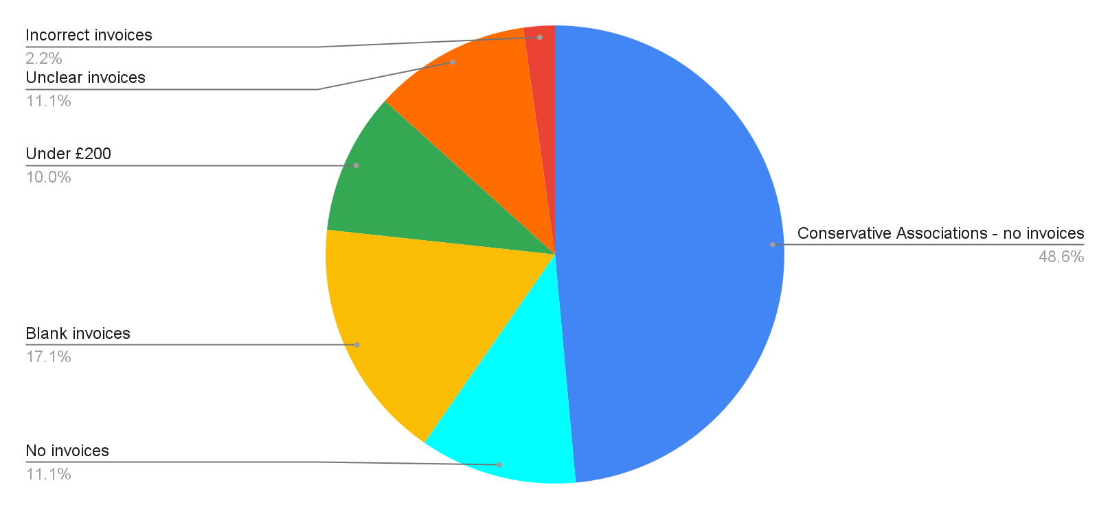
Source: Authors´ analysis of invoices returned to the Electoral Commission for the 2019 General Election.

The research team also examined the possibility that different parties would not be equally likely to submit spending returns with unclear entries. Looking at which parties were responsible for what percentage of unclear invoices; Figure 5 shows that the vast majority (59 per cent) were returned by the Conservatives (reflecting the large number of CAs). The Liberal Democrats were the party responsible for the next highest percentage of unclear invoices, at 17 per cent, with Reform UK featuring third at 8 per cent.

Figure 5: Percentage of unclear invoices that each party was responsible for, UK General Election 2019
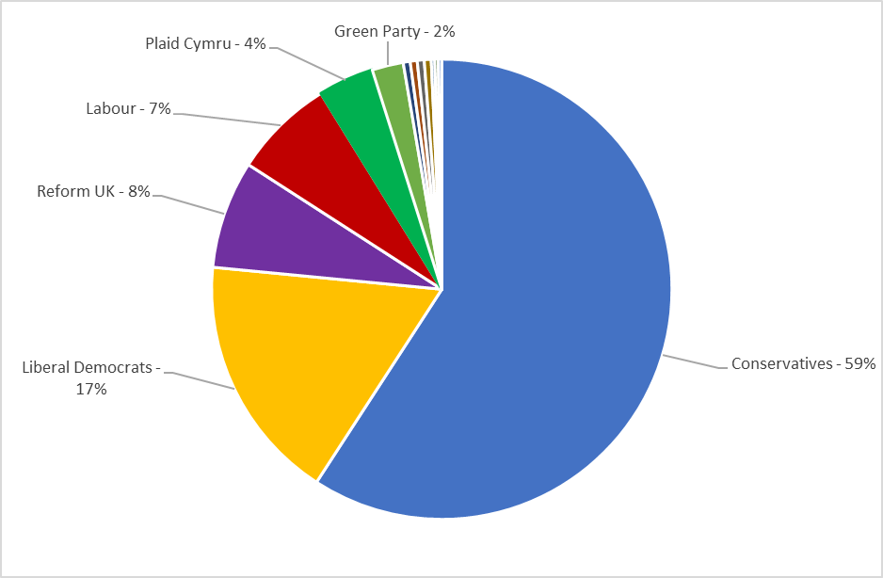
Source: Authors´ analysis of invoices returned to the Electoral Commission for the 2019 General Election.

In looking at this data, however, it is important to note that parties varied dramatically in terms of the number of suppliers that they worked with. Table 3 shows the number of suppliers with unclear invoices as a percentage of the total number of suppliers a party worked with. This reveals that the invoices submitted by some parties, such as Plaid Cymru, were nearly always unclear—with 94 per cent of Plaid Cymru’s invoices coded as unclear, as were all of the Social Democratic Party’s. These findings suggest that political parties should work with EMBs to provide training and support for employees who upload invoices to improve transparency—and that EMBs may wish to target this support at certain parties with the highest proportions of unclear invoices.

Table 3: Percentage of suppliers with at least one completely unclear entry by party and number of total suppliers, UK General Election 2019
Party | Total no. of suppliers | No. of suppliers with unclear invoices | % unclear
Conservatives | 358 | 242 (inc. 219 CAs) | 68% (6% after excluding CAs)
Labour | 202 | 29 | 14%
Liberal Democrats | 284 | 71 | 25%
Reform UK | 85 | 31 | 36%
Scottish National Party | 36 | 2 | 6%
Green Party | 52 | 9 | 17%
Plaid Cymru | 17 | 16 | 94%
UKIP | 4 | 1 | 25%
Co-Op Party | 10 | 2 | 20%
Democratic Unionist Party | 5 | 1 | 20%
Advance Together | 4 | 2 | 50%
Social Democratic and Labour Party | 2 | 2 | 100%
The Cynon Valley Party | 2 | 1 | 50%
Source: Authors´ analysis of invoices returned to the Electoral Commission for the 2019 General Election.

These instances also suggest that there is a case for the greater standardization of disclosure practice. This recommendation mirrors existing calls for ‘standardised disclosure forms’ in the US (Heerwig and Shaw 2014) or ‘common accounting practices’ in the UK (Power 2020b), that aim to reduce variation in the information released. Based on the analysis, there appears to be a particular need to provide a common template for disclosure, but also to ensure that invoices are uploaded in the same format and resolution to ensure that they can be read. In addition, the existence of vague and uninformative invoice descriptions suggests the need for additional guidance on the level of detail that is required within the invoice description. At present in the UK, the Electoral Commission (2019: 27) states that invoices need to record ‘what the spending was for – for example, leaflets or advertising’. The findings from this study suggest that there is a need to specify further granularity of services, calling for precise detail of what the spending was for, with a full description of the range of tasks conducted by the supplier. To aid compliance, examples should be provided that illustrate the need to avoid catch-all descriptions, and to provide more specific accounts of the range of tasks conducted. EMBs may also want to consider expanding the transparency regime to require not just political parties, but also suppliers to complete returns detailing commercial activity within the election period.

In addition to these recommendations, this report also draws on the experience of conducting this analysis to make a further recommendation around the accessibility of this data for researchers. At present in the UK, the Electoral Commission makes it possible to download a .csv file detailing the spending figures and categories, and yet it is not possible to bulk-download the invoices. This means each individual invoice needs to be clicked on manually, opening a new window. To enable future analysis, electoral regulators internationally should facilitate the analysis of invoices, making it possible to download this resource. It would also be beneficial to explore text extraction from these invoices to allow researchers to conduct keyword searches on their content. Mirroring best practice in the USA (FEC n.d.), it is recommended that electoral regulators should establish an application programming interface (API), which will better allow researchers (and interested observers) a more efficient way of exploring how campaigns are fought and funded. Where possible, EMBs across the world should also request detailed and standardized invoices, and where they already do, make these accessible to researchers.

Considerations for the UK Electoral Commission
- Create a standard template for invoices for election expenses to ensure consistency in reporting and formatting.
- Produce standard guidance for the uploading of invoice images to ensure that all images are clear and consistently formatted.
- Update existing guidance for parties on the detail required for spending returns, to ensure that specific items of expenditure are included.
- Configure transparency databases to ensure that researchers can easily access and analyse invoices, particularly looking to enable mass download and text extraction.
- Explore possibilities for expanding the transparency regime to require not just political parties, but also suppliers to complete returns detailing commercial activity within the election period.

Considerations for political parties
- Work with EMBs/political finance oversight bodies to provide training and support for employees who upload invoices to ensure that they meet best practice standards.
- Record more precisely what roles suppliers are performing for them to allow more accurate classification of campaign activity.
- Take ownership in establishing best practices to minimize unclear invoice returns.
- Where legislation does not require it, political parties should provide standardized invoices to suppliers.
- On agreement of provision of service, political parties should make clear the level of detail that suppliers should state on invoices about the service they perform.

Section summary

- More than two in five suppliers provided at least one invoice that didn’t clearly indicate the service that they were providing.
- This was largely due to the prevalence of Conservative Party Constituency Associations, which didn’t report any spend (48.6 per cent), although a significant number of suppliers also provided at least one blank invoice (17.1 per cent).

Current sanctions against parties made by the UK Electoral Commission for non-compliant spending returns
As well as reporting campaign donations and spending over a certain threshold, the Electoral Commission is also responsible for investigating cases of campaigns not properly disclosing their financial arrangements. In terms of campaign spending, this means failing to provide a complete and accurate account of all instances of spending over GBP 200 within the specified timeframe. Investigations arise through a combination of: (a) proactively monitoring compliance with PPERA; (b) acting upon complaints (Electoral Commission 2016b) that campaign organizations have broken the law; and (c) acting upon evidence from media reports (Electoral Commission 2016b) and other regulators. The Electoral Commission then decides whether to open a formal investigation based on the severity of the offence (Electoral Commission 2021) and the strength of the evidence, as well as whether the party in question has a history of non-compliance and has not yet taken steps to rectify their malpractice. The results of these investigations are published on the Electoral Commission’s website, alongside investigations into other aspects of malpractice, such as the improper declaration of political donations.

In total, 23 investigations were conducted into the reporting of campaign spending in the wake of the 2019 General Election, the outcomes of which are shown in Table 4. The Electoral Commission was satisfied that an offence was committed in 13 of these investigations, meaning that the party or campaign organization in question either provided late, incomplete, or otherwise non-compliant spending returns. Only five of these offences were judged to be serious enough to warrant a financial penalty, and all offences under investigation were committed by minor parties who only stood candidates in a small number of constituencies (although the Electoral Commission did issue significant fines to the Conservatives (Electoral Commission 2017) and the Liberal Democrats (Electoral Commission 2016c) for not delivering compliant spending returns at the 2015 General Election).

While providing some insight into how cases of malpractice are identified and dealt with, there are many unanswered questions about how this process works. First, it is not clear how many complaints are made, or by whom. Second, although the Electoral Commission does provide guidance on how it carries out its investigations on its website (Electoral Commission 2021) and it publishes its enforcement policy (Electoral Commission 2016b), it is still at times unclear as to how it arrives at specific judgements about: (a) the threshold for a suspected offence to warrant an investigation; and (b) when an offence is deemed serious enough to warrant a sanction. This is predominantly due to the results of each investigation only being described in a brief note on the Electoral Commission website, but also because many cases where a sanction was avoided cite ‘mitigating’ factors that are not detailed, making it difficult to determine why this outcome was reached.

The present guidance from the Electoral Commission states that it issues ‘proportionate’ sanctions that are in the public interest, but it does not provide further detail regarding what proportionate means in practice. It is therefore suggested that in the UK more specific guidance on the procedure of issuing sanctions, as well as more detailed reporting of complaints and individual investigations, would ensure greater transparency. Worldwide, procedures for investigation into campaign spending offences should replicate these standards to ensure that complaints information is easy to access and transparent.

Table 4: Electoral Commission investigations into inadequate reporting of campaign spending, UK General Election 2019
Party/Organization | Offence | Sanction
Renew | Late delivery of campaign expenditure return | GBP 2,800 fine
Scottish Green Party | Failure to deliver accurate spending return | GBP 200 fine
The Cynon Valley Party | Failure to deliver complete spending return | No sanction
Capitalist Worker | Failure to deliver compliant spending return | No sanction
The Citizens Movement Party | Late delivery of campaign spending return | No sanction
The Justice & Anti-Corruption Party | Late delivery of campaign spending return | No sanction
Gwlad | Late delivery of campaign spending return | GBP 200 fine
Mebyon Kernow: The Party for Cornwall | Late delivery of campaign spending return | GBP 200 fine
British National Party | Late delivery of campaign spending return | GBP 300 fine
Space Navies | Failure to deliver a signed declaration of spending | No determination of offence
Church of the Militant Elvis Party | Late delivery of campaign expenditure return | No offence
Lincolnshire Independents | Late delivery of campaign expenditure return | No determination of offence
Independent Group for Change | Failure to deliver accurate spending return | No offence
Communities United Party | Failure to deliver spending return | No offence
Parent’s Choice | Failure to deliver accurate spending return | No determination of offence
Sinn Féin | Failure to deliver accurate spending return | No sanction
Independent Network | Late delivery of campaign spending return | No sanction
Scientists for EU | Failure to deliver accurate spending return | No sanction
Working 4 UK | Failure to deliver complete spending return | No sanction
Greenpeace | Failure to deliver complete spending return  Late delivery of campaign spending return | No offence
Tactical.vote | Failure to deliver complete spending return | No offence
Fair Tax Campaign | Failure to deliver complete spending return | No offence
Global Justice Now | Failure to deliver all invoices | No offence
Source: UK Electoral Commission. (no date) ‘Investigations’, available at: https://www.electoralcommission.org.uk/who-we-are-and-what-we-do/our-enforcement-work/investigations.

Considerations for the UK Electoral Commission include:
- Establish clearer and more transparent processes for reporting all cases of suspected financial reporting malpractice examined, including those that are not eventually subject to a full investigation. This should involve reporting outcomes at each stage and declaring the criteria used to determine the action taken.

Section summary

- 23 organizations were investigated for non-compliant reporting of their campaign spending, 13 of which were deemed to have committed an offence.
- Only five parties committed offences that were considered serious enough to warrant a financial penalty (the maximum of which was GBP 2,800).
- None of the parties investigated were the ‘main’ parties at the 2019 General Election, although the Conservatives and the Liberal Democrats faced significant fines in other recent UK elections.

Chapter 4

Recategorizing the database
Having reviewed general insights on transparency and spending from the Electoral Commission database, the report now considers what else can be discovered about suppliers’ activities within election campaigns. At present, the Electoral Commission provides 10 categories that are used to classify the type of service a supplier provides. These categories have been widely critiqued and are kept under review by the Electoral Commission itself. The problem is related to the breadth and relevance of these category headings—they provide limited detail of the precise service being performed for parties, and these longstanding headings fail to capture more modern forms of campaigning activity. The consistency with which these categories are applied is also an issue, as suppliers providing apparently single services are often classified under different categories. In the research team’s analysis, for example, invoices from Facebook were classified as advertising, media, unsolicited material to electors, and overheads and general administration. While these differences may reflect different services, they may also reflect different interpretations by parties of the correct reporting category—making it difficult to use Electoral Commission headings to gain an impression of what these suppliers are actually doing. Moreover, between a Facebook invoice submitted as ‘advertising’ and one submitted as ‘media’, there is little functional difference.

For these reasons, there have been calls to revisit the spending categories, to provide more precise and informative headings (Dommett and Power, 2019). At present the Electoral Commission is itself conducting a review on this topic in an attempt to allow for a more granular analysis of spending patterns. To date, however, changes have not been made.

In seeking to gain a more detailed picture of what exactly different suppliers were doing for parties, the research team classified the activity recorded within each invoice. This involved describing the activity the team thought the invoice listed, comparing, and contrasting the descriptions produced by different coders, and refining and applying a list of new headings that captured all the types of activity observed. This allowed the team to build up a more detailed picture of what suppliers were doing, but also to assess the extent to which the Electoral Commission’s categories were capturing suppliers’ activities. This section of the report outlines these categories in greater detail, before analysing the distribution of suppliers’ activities across these categories in terms of frequency and spend.

Introducing the new categories
As detailed in the Appendix on Methodology, the research team developed nine overarching categories that capture the range of activity found within invoices. These categories are:

- advertising and press;
- campaign materials;
- campaign activity;
- production;
- research;
- data and infrastructure;
- consultancy;
- miscellaneous; and
- completely unclear.

Each category contains constituent subcategories, described throughout this section, which give more detail about the particular kind of activity taking place. Where an activity either straddles a number of these subcategories or was so broad as to not fall into a subcategory, the research team coded it under the general overarching category heading (for more detail on this process see the Appendix on Methodology).

Figure 6: The distribution of spend across the new categories, UK General Election 2019
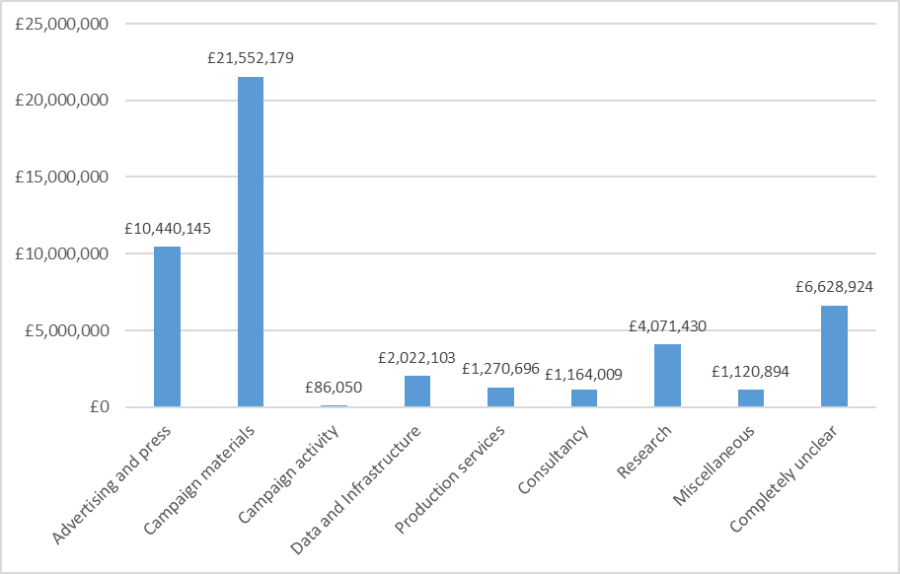
Source: Authors´ analysis of invoices returned to the Electoral Commission for the 2019 General Election.

What do these new categories reveal?
Below, we consider what the new categories reveal about campaign practices, and how they compare with those which campaigners assign under the Electoral Commission’s groupings. Taking each of the new category headings in turn, this report provides a brief overview of the findings and reflects on what additional information this reveals about the utility of existing spending categories, inferring what can be learnt in terms of understanding the role of suppliers in elections across the world.

To begin, it is useful to look at Figure 6, which details the distribution of spend across the new headline categories (the subcategories are discussed further below). This reveals that suppliers primarily worked on campaign materials or advertising. Significantly less was spent on activities categorized as research, data and infrastructure, consultancy or production. The difference between the largest and smallest of the new categories—campaign material and campaign activity—suggests that, while parties expend significant resources in communicating with voters via different media, they spend hardly anything on campaign activity via external suppliers. This could suggest that parties no longer engage in certain campaign activities, or that parties do not spend significant amounts on this activity. This second theory is supported by prior research that highlights parties’ reliance on voluntary labour for activities such as canvassing (Bale et al. 2020), but it is a question that this report unpicks further below.

Exploring the data in more detail, this report looks at each category in turn.

Advertising and press
A total of GBP 10,440,145 of spending was categorized under the new category heading of ‘advertising and press’. This differs from the Electoral Commission’s collective spend under two categories of ‘advertising’ and ‘media’ of GBP 14,995,916 and means that approximately GBP 4.5 million of expenditure currently declared to the Commission as advertising is better understood under a different category.

To generate more understanding of the different types of advertising that suppliers are delivering for parties, the research team identified six subcategories that can usefully be used by scholars in the UK and elsewhere (see Table 5).

Table 5: Subcategories for the ‘advertising and press’ category, UK General Election 2019
Advertising and press | Invoices which referred to advertising activity (either in newspapers, online or elsewhere) or press services such as PR. This category has six subcategories. | Total spend:  GBP 10,440,145
Advertising and press | Where services fell under the general category of ‘advertising and press’ | GBP 579,500
Merchandise | Production of campaign bric-a-brac such as boxing gloves, umbrellas, wrapping paper, badges, rosettes and balloons | GBP 302,183
Newspaper or magazine advertising | Paid adverts in national or regional news outlets (either in print or online versions) | GBP 1,381,771
Social media advertising | Paid adverts placed on social media platforms (for example, on Facebook, Instagram or Snapchat) | GBP 5,757,592
Online advertising | Generic paid web adverts | GBP 1,861,117
Other forms of advertising | Paid advertising in a form that doesn’t necessarily fit into any of the above categories and includes the use of ‘ad vans’ and paid billboard adverts | GBP 534,507
PR | Paid public relations content and advisers | GBP 23,475
Source: Authors´ analysis of invoices returned to the Electoral Commission for the 2019 General Election.

The subcategories reveal that social media and online advertising dominate the overall picture of advertising and press spend (see Figure 7), in total accounting for GBP 7,618,709 of overall expenditure in this category (73 per cent). Newspaper or magazine advertising, on the other hand, accounts for GBP 1,381,771 of total spend in this category (13.2 per cent). This suggests that calls for increased regulation (Electoral Commission 2018) of online advertising and campaigning appear to be well placed, as significant resource is being devoted to this activity.

Figure 7: The distribution of spend across the ‘advertising and press’ subcategories, UK General Election 2019
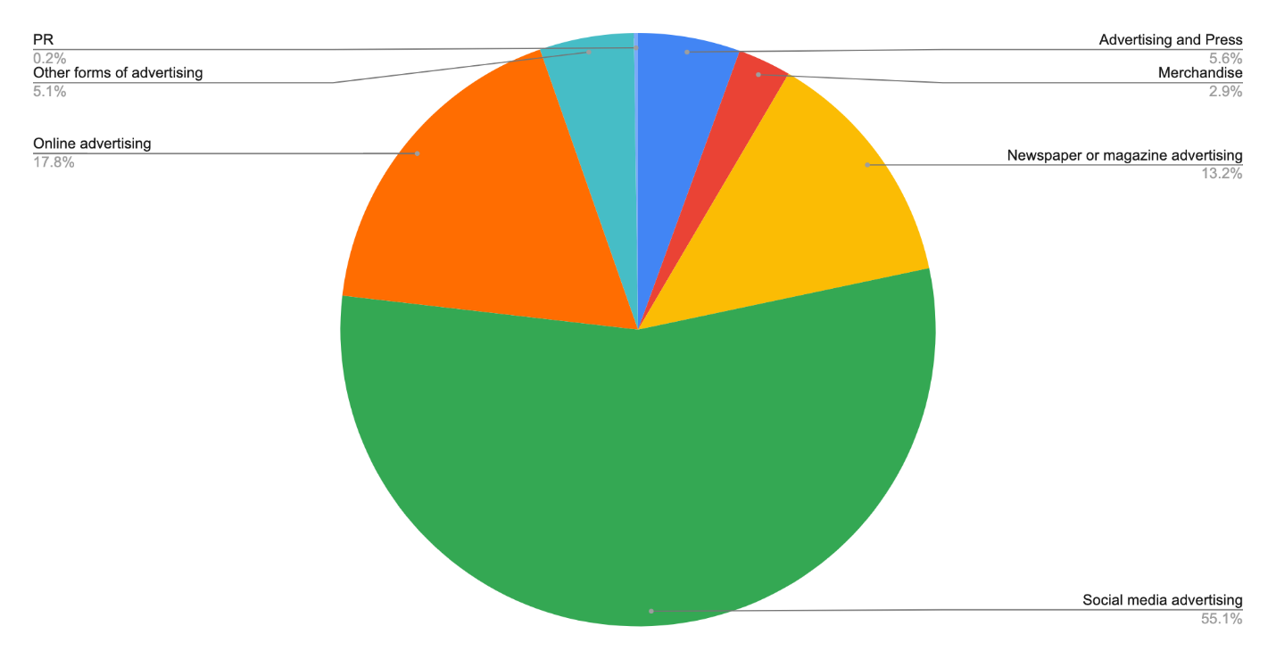
Source: Authors´ analysis of invoices returned to the Electoral Commission for the 2019 General Election.

One major supplier of advertising was Facebook. Within the analysis, this company was only coded as supplying social media advertising, with invoices describing either the placement or messaging testing of adverts. In contrast, in the Electoral Commission database, Facebook appeared under several categories, showing the inconsistency with which parties are currently applying coding categories and a need for EMBs to provide clearer guidance on how spending with this supplier should be declared.

Considerations for the UK Electoral Commission include:
- Provide clearer guidance and examples of which activities fall under which categories, specifically in relation to technology and data infrastructure.

Campaign materials
While online and social media advertising appears to be an important campaign activity, the research team’s coding also shows that by far and away the largest proportion of campaign spend is devoted to campaign materials. Indeed, the analysis shows that GBP 22,261,734 of spending fell into this category, accounting for 47.6 per cent of the total election spend analysed in this project. The research team identified six subcategories (see Table 6).

Table 6: Subcategories for the ‘campaign materials’ category, UK General Election 2019
Campaign materials | Invoices which referred to the physical objects used for campaigning, or tangible events (e.g. rallies) or processes (e.g. mailing leaflets) related to campaigning more generally. This category has six subcategories. | Total spend: GBP 21,552,179
Campaign materials | Where services fell under the general category of ‘campaign materials’ | GBP 50,357
Design services | Design of resources, such as leaflets, manifestos or other mentions of ‘design’ work | GBP 75,208
Campaign material printing | Printing of materials containing information about the campaign itself (such as leaflets, poster boards and correx boards). Payment for the photocopying of leaflets is also included in this subcategory | GBP 9,050,63
Paid leaflet delivery/postage | Delivery of a tranche of materials to specific addresses. This subcategory did not include general delivery of goods/campaign materials to constituency offices or campaigners’ addresses | GBP 10,665,842
Event costs/venue hire | Venue hire for a rally, or other events that relate to campaigns more generally | GBP 1,627,539
Creative content owned by a third party | Third-party content (such as Getty Images or demo music) | GBP 41,034
Translation/Braille/British sign language | Translation services are employed, whether for leaflets, manifestos or during a rally/speech | GBP 41,563
Source: Authors´ analysis of invoices returned to the Electoral Commission for the 2019 General Election.

Table 7 and Figure 8 show that GBP 19,716,479 (91.4 per cent) was spent on either campaign material printing or paid leaflet delivery. The other activities identified commanded minimal spend.

Figure 8: The distribution of spend across the ‘campaign materials’ subcategories, UK General Election 2019
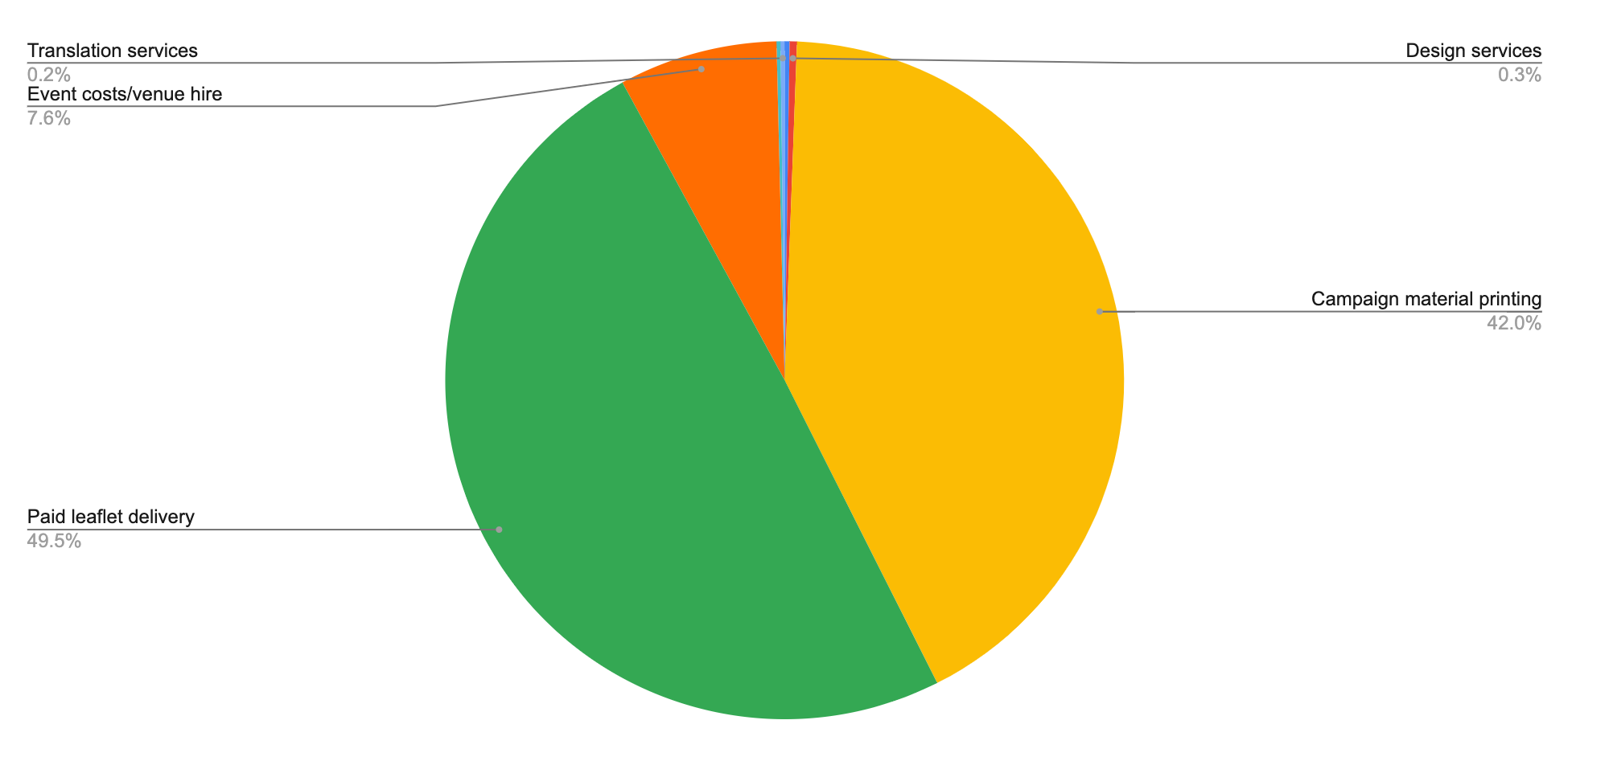
Source: Authors´ analysis of invoices returned to the Electoral Commission for the 2019 General Election.

Looking at the three highest spending subcategories, it is possible to see that the analogous categories used by the Electoral Commission are unsolicited material to electors, rallies and other events, and manifesto or referendum material. Across these three categories GBP 23,278,010 of spending is declared to the Electoral Commission, suggesting high alignment between the new category and these existing Electoral Commission categories. EMBs and electoral monitors can and should continue to rely on traditional categories even when investigating modern elections, and in particular the role of printed materials, including posters, leaflets and traditional mail.

Considerations for UK Electoral Commission include:
- Prepare their investigations of elections with an understanding of the potential dominance of social media advertising and traditional understandings of advertising and press as established areas of resource within political campaigns.

Campaign activity
The research team separately coded the few references to outreach and mobilization as examples of ‘campaign activities’. This category contained two subcategories: fundraising and phone-banking (see Table 7).

The minimal invoices and spend in this area can be explained in different ways. First, a great deal of what might be understood as campaign spending may well take place outside of regulated campaign periods. Fundraising is a good example of this: political parties often conduct fundraising far ahead of an election to build war chests for election periods. Second, much campaign activity (such as phone-banking) is conducted by volunteers (see Bale et al. 2020). This voluntary service makes campaign activity relatively cheap and results in limited spend. This highlights the importance of equating spend to value. Many of these activities for parties can be conducted at low (or no) cost but are essential to the running of a successful campaign. Third, under electoral law parties are not allowed to explicitly spend money on certain campaign activities (such as anything explicitly relating to ‘get-out-the-vote’). As such, the research team did not expect to find much reference to these kinds of activities in returns. In response to the first of these trends, it is recommended that EMBs in the UK and beyond extend financial reporting requirements outside of election periods to enable further scrutiny of party spend.

Table 7: Sub-categories for the ‘Campaign Activity’ category, UK General Election 2019
Campaign activity | Invoices relating to the process of campaigning (i.e. encouraging people to vote) as opposed to the specific materials used. This category has two subcategories. | Total spend: GBP 86,050
Campaign activity | Where services fell under the general category of ‘campaign activity’ | GBP 0
Fundraising | Activity specifically designed around raising further funds for the campaign itself | GBP 7,610
Phone-banking | Activity specifically referring to the use of phone banks to canvass support | GBP 78,440
Source: Authors´ analysis of invoices returned to the Electoral Commission for the 2019 General Election.

Production
One of the categories that emerged from the research team’s coding that does not mirror existing Electoral Commission headings focused on production. Within this category, the team identified three subcategories that distinguished different types of activity (see Table 8). Video editing/production was the primary focus of spending, standing at GBP 970,534 or 76.3 per cent of the total category spend. In total, expenditure coded as production accounted for GBP 1,270,696 or 2.6 per cent of overall spend. The closest analogue within the Electoral Commission database is ‘campaign broadcasts’ (GBP 760,926), which is a difference of compared spend of GBP 509,770.

The analysis showed that many of the activities the research team coded as referring to production were often declared by parties under the Electoral Commission headings as relating to advertising, manifesto or referendum material, media, or overheads—showing that spend on this activity is declared inconsistently. This also shows the limit of what can be understood from looking at invoices: what suppliers provide may not be equal to an outcome, or how political parties use inputs from the suppliers. For example, a video can be produced by a supplier (video editing/production) but used at a rally (event costs/venue hire) or within a campaign manifesto (campaign materials) by the party.

Table 8: Subcategories for the ‘production’ category, UK General Election 2019
Production | Invoices referring to production contained services relating to the creation of campaign content for wider dissemination (e.g. party election broadcasts and Facebook videos). This category has three subcategories. | Total spend: GBP 1,270,696
Production | Where services fell under the general category of ‘campaign activity’ | GBP 193,875
Video editing/production | Video-related editing and production | GBP 970,534
Audio editing/production | Audio-related editing and production | GBP 6,782
Photo editing/production | Photo-related editing and production | GBP 99,505
Source: Authors´ analysis of invoices returned to the Electoral Commission for the 2019 General Election.

Research
The research team’s coding also produced the category heading ‘research’, which for the most part mirrored the ‘market research/canvassing’ category offered by the Electoral Commission. Capturing a slightly narrower range of activities, the team coded GBP 4,071,650 of spend under this heading, as opposed to the GBP 6,409,704 declared to the Commission as market research/canvassing.

Table 9: Subcategories for the ‘research’ category, UK General Election 2019
Research | Invoices relating to research contained activity designed to allow parties to gather intelligence during (and prior to) campaigns. This category has six subcategories. | Total spend: GBP 4,071,430
Research | Where services fell under the general category of ‘research’ | GBP 1,191,200
Polling | Fielding and/or reporting of opinion polls | GBP 2,285,257
Focus groups | Research organizations to conduct focus groups | GBP 106,160
Ordnance Survey data | Data specifically supplied from Ordnance Survey for campaign activities | GBP 151,458
Message testing | Campaign message testing services, or accommodate message testing more generally | GBP 308,885
Archival research | Historical and archival research | GBP 1,080
Other forms of research | Paid research that doesn’t fit into the above categories (e.g., NHS data extraction) | GBP 27,609
Source: Authors´ analysis of invoices returned to the Electoral Commission for the 2019 General Election.

This category was composed of six subcategories that capture the diversity of research activity that suppliers are paid to conduct (see Table 9). Parties declared the highest spend on polling and general research activities—with these activities together accounting for GBP 3,476,457 (or 85.4 per cent) of the total research expenditure. The other forms of research, such as focus groups and archival research, demanded less spend. However, as suggested above, it may be that funding is devoted to these activities ahead of the election period when formulating campaign messaging. Notably, within this category there is also limited spend devoted to message testing. This indicates that—despite an emphasis on data-driven campaigning and message testing—this technique is either not extensively used, or that the analysis of the findings from social media advertising is conducted by in-house staff, or that message testing is part of the wider ‘social media advertising’ service that providers like Facebook offer (as the research team found when coding the Facebook invoices).

Data and infrastructure
The category of data and infrastructure captures a particular type of activity not differentiated in the current Electoral Commission category headings, which relates to parties’ data infrastructure and technological operations. This category accounts for GBP 2,022,103 or 4.2 per cent of total expenditure. The research team identified seven subcategories that capture activity devoted to, for example, campaign databases, IT infrastructure and websites (see Table 10). The three most prominent subcategories under this heading are IT infrastructure and support (GBP 696,140), campaign database management (GBP 644,362), and data services and analysis (GBP 302,140). What is, however, again unclear is how much is devoted to these activities outside elections, when systems and infrastructure are just as likely to remain a focus of investment.

Table 10: Subcategories for the ‘data and infrastructure’ category
Data and infrastructure | Invoices referring to the use of technology in driving campaign mechanisms, including infrastructure, data analysis and website services. This category has seven subcategories. | Total spend: GBP 2,022,103
Data and infrastructure | Where services fell under the general category of ‘data and infrastructure’ | GBP 163,371
Campaign database or CRM | Customer relationship management (CRM) services or databases, such as Contact Creator, NationBuilder and Voter Vault | GBP 644,362
Data services and analysis | Data management, data analysis, list building, data collection, voter file matching and identity resolution/data matching | GBP 302,140
IT infrastructure and support | Software, software development servers, cloud computing and the purchasing of desktop and laptop computers | GBP 696,140
Telecommunications services | Purchase and upkeep of telecommunication systems | GBP 59,371
Mobile application services | Development for mobile phone apps for political parties and campaigns | GBP 77,379
Email services | Upkeep of email servers | GBP 15,367
Website services | Update and development of websites | GBP 63,973
Source: Authors´ analysis of invoices returned to the Electoral Commission for the 2019 General Election.

Comparing this category with parties’ own coding of these activities under the Electoral Commission’s headings shows that parties tend to declare these kinds of spend as overheads and general administration, market research/canvassing, advertising or media. There is significant variation in how even the same activity is declared, suggesting that the Electoral Commission’s headings are not effective at consistently capturing this kind of activity. EMBs could create clearer categories for capturing the work utilizing digital technologies, data and infrastructure. These new subcategories can be a basis for beginning this work.

Considerations for the UK Electoral Commission include:
- Consider having a greater number of categories provided to political parties, to more accurately reflect the range of modern campaign activities. These categories should be reviewed regularly in consultation with parties.

Consultancy
Another new category that emerged related to consultancy activity, which the team defined based on invoices using the term consultancy/consulting as a singular activity or making reference to strategic or managerial input to the campaign. It is largely a new category without an easy analogue in the Electoral Commission returns.

Table 11: Subcategories for the ‘consultants’ category
Consultants | Invoices coded under this category referred to services on strategy, management or consultancy. This refers to instances in which actors are giving strategic advice (as opposed to delivering content or services). This category has four subcategories. | Total spend: GBP 1,164,009
Consultancy | Where services fell under the general category of ‘consultancy’ | GBP 556,529
Communication consultants | Strategy and advice around video, online or offline communications | GBP 359,466
Design consultants | Strategy and advice around the design of certain materials and messages | GBP 101,020
Social media strategy and consultancy | Strategy and advice specifically relating to social media plans | GBP 9,533
Data consultancy | Strategy and advice around the utilization of data in campaigns | GBP 137,460
Source: Authors´ analysis of invoices returned to the Electoral Commission for the 2019 General Election.
Under this heading, the research team identified four subcategories that captured total expenditure of GBP 1,164,009, or 2.4 per cent of total spend examined (see Table 11). This revealed a variety of different types of consultancy work, with general consultancy being the primary service provided, at GBP 556,529. A not insignificant amount of money was spent on communication consultants (GBP 359,466) and on design consultancy (GBP 101,020). Less than expected was spent on consultants specifically working on social media (just GBP 9,533), a particularly striking finding given the prominent emphasis on social media advertising at recent elections and the spend coded under this advertising category. This suggests that either parties are designing and fielding their own advertising online, rather than paying external consultants to perform this role, or that this kind of work is conducted as part of a more generalized consultancy package.

Interestingly, the invoices identified as related to consultancy were mostly categorized under the Electoral Commission’s headings of ‘overheads and administration’ or ‘advertising’, suggesting once again that existing categories are not adept at accurately and consistently capturing different types of activity that is done at the senior or strategic level by suppliers. EMBs should provide a greater number of categories which reflect this activity. In addition, political parties in any country should give more detail on the services conducted by suppliers when reporting their spends.

Miscellaneous
The final substantive category, miscellaneous, captured a range of activity that the research team felt did not fall within the other categories. It was composed of eight subcategories: miscellaneous, catering, accommodation, expenses, office supplies, physical security, recruitment and transport (outside of the Electoral Commission’s transport category that had already been excluded). These headings accounted for GBP 1,120,894 of total expenditure (2.3 per cent).

Unclear
Finally, as discussed in section 2.2, the research team’s coding also revealed a number of ‘completely unclear’ invoices. Strikingly, these invoices account for GBP 6,628,924 (or 13.7 per cent) of total spend investigated from the 2019 General Election. This means that it is unclear what over 1 pound in every 10 was spent on. It is also worth stating that this characterization is likely to be on the low side. There were many invoices that weren’t completely unclear, but which gave very little detail about the specific activity (examples given above include that of the general ‘research’ and ‘consultancy’ categories), meaning that they may have been coded under categories that do not truly reflect the activity undertaken.

Section summary

- Existing Electoral Commission categories have been criticized for being broad, outdated and inconsistently applied, creating a need for new categories to be developed—in particular, in relation to new forms of campaigning, whereas traditional forms, such as advertising, press and campaign materials, need more detail.
- By far the most prominent form of spending by parties (accounting for over GBP 21 million) was on campaign materials, principally in the form of printing and delivery of these materials to voters (45 per cent of total election expenditure).
- Advertising was the next most costly type of spending (over GBP 10 million), 73 per cent of which was online in the form of social media ads or wider digital advertising.
- Over GBP 6.5 million of spending was provided on invoices which, for some reason, were not clear. This means that nearly 14 per cent of spending coded was obscured in some way.
- Spend on a number of types of activity—such as data, technological tools and infrastructure, and various forms of consultancy—are obscured by current Electoral Commission categories.
- Parties are presently unclear which Electoral Commission categories are most suitable for certain types of spending—with activity around production and infrastructure currently coded in many different places.

Which activities did the research team expect to see but are missing in spending returns?
The research team’s analysis of the invoices provided to the Electoral Commission offers a range of further insights into the role of suppliers in election campaigns, and yet it also raises questions about what is missing from, or only occasionally present within, these invoices.

Looking first at the new categories that returned only a few entries, it is notable that a raft of online and data-related activities features minimally. Only eight suppliers are providing ‘online advertising’ and four provide social media strategy and consultancy. In terms of digital infrastructure, just four providers reported mobile application services, but even in terms of more mundane infrastructure, only six suppliers provided email services and eight website services. Similarly, on data, eight suppliers reported activity on ‘data services and analysis’, two were coded as ‘data consultancy’, while seven worked on ‘campaign database or CRM’ and four conducted ‘message testing’.

In many cases, these suppliers—despite being small in number—were receiving significant amounts of money. In particular, in terms of online advertising, only eight suppliers accounted for GBP 1,861,117 of spending (largely due to Google). Similarly, while only four suppliers provided mobile application services and two suppliers were data consultants, the spend was high, at GBP 77,379 and GBP 137,460 respectively. However, the four consultants providing specific social media strategy advice amounted to just GBP 9,533. A small number of suppliers does not necessarily equate to a small overall spend, and particularly when it comes to data-driven and digital services, only a few suppliers are performing these activities during elections.

The research team also expected to find certain types of campaigning activity that were not referred to in invoices. In terms of digital activity, for example, there was little evidence of search engine optimization or social/digital listening. They also didn’t find specific suppliers working discreetly on activities such as data management, list building or voter file matching—leading them to create the catch-all category of data services and analysis, which contained just six entries. The lack of suppliers working in this area is particularly striking given the significant attention that has been paid to this kind of work in recent academic and popular commentary. This raises questions about the degree to which parties are paying external suppliers to conduct data and analytics work and why suppliers and researchers are giving so much attention to this type of work (a question this report returns to below).

Beyond the digital realm, it is also notable that activity around mobilization is conspicuously absent. While the research team found a large number of suppliers being paid to deliver leaflets, relatively few worked on canvassing or fundraising activity. One possible explanation for these absences is that these invoices relate to spending only incurred during the election period. Some activities—such as voter mobilization or registration, for example—may occur outside the election period. Similarly, campaigners may invest funds in building and maintaining databases prior to the election period, meaning that such activity is not apparent in returns.

Considerations for CSOs include:
- When conducting work to increase transparency and accountability of political parties, extend the time period in which CSOs’ research takes place, to consider the substantial work of campaigns and suppliers outside election periods.

Section summary

- The analysis identified several categories that contained very few suppliers. This was occasionally true even when the levels of spend were significant; for example, GBP 1.86 million was spent on online advertising between only eight suppliers.
- The research team also found that many services they had expected to see were either not reported in invoices, or featured only sparingly, specifically in relation to digital and data services.

Chapter 5

What can additional transparency reveal about company activities?
While the research team’s coding offers several insights into what is and isn’t contained within the invoices, there remain many further questions that it is not possible to answer with the existing information disclosed to the Electoral Commission.

Primarily, a question emerges about the extent to which parties are only conducting activities that appear in the Electoral Commission categories or this project’s coding of invoice descriptions. In particular, the research team was keen to further explore whether the lack of apparent activity in the area of data and digital technology was accurate or reflected ambiguities in the available data.

To consider this possibility, the research team drew on other sources of information to investigate whether certain companies were potentially delivering services not captured by either the Electoral Commission categories or by the descriptions given on invoices. Specifically, the team investigated a number of suppliers who received a high spend, where there was limited detail on the kind of activities that they were conducting. This involved searching for other publicly available information about these suppliers, looking at records in Companies House, at their websites, and at news stories related to their origins and electoral activity. Specifically, the research team looked at seven companies in Table 12. This report does not name the specific companies examined but offers them as indicative examples to consider what is absent from existing transparency returns.

Table 12: Suppliers commanding significant spend but whose invoices were unclear about services
 | Spending | Electoral Commission category | New category/ies
Conservative Party suppliers
Supplier 1 | GBP 1,689,000 | Market research/canvassing | Research; Polling
Supplier 2 | GBP 708,000 | Market research/canvassing | Completely unclear
Supplier 3 | GBP 418,400 | Advertising | Completely unclear
Supplier 4 | GBP 139,800 | Overheads and general administration | Consultancy; Research
Labour Party suppliers
Supplier 5 | GBP 575,000 | Advertising | Advertising and press
Supplier 6 | GBP 188,328 | Advertising | Newspaper or magazine advertising;  other forms of advertising (billboards, advans, digital posters outside); Consultancy
Supplier 7 | GBP 86,154 | Overheads and general administration;  market research/ canvassing | Mobile application services; Completely unclear
Source: Authors´ analysis of invoices returned to the Electoral Commission for the 2019 General Election.

Looking at the additional detail, the research team found that a number of these companies advertise themselves as offering different services from those suggested by Electoral Commission categories and this project’s invoice coding. Beginning with the Conservative Party, Supplier 1 was the one with the single largest spend, and yet there was exceedingly limited detail about their activity. Invoices largely either described the work as ‘For Research’ (coded in the new ‘research’ category and accounting for GBP 1,065,000 of spend with this supplier), or ‘For research poll’ (coded in the new ‘polling’ category and accounting for GBP 624,000 of spend with this supplier). When looking at the company’s website, however, a far wider range of services are provided, including offering ‘Digital expertise’, ‘Reputation management’ and ‘Support in the field’. Expanding on this last service, the company describes how it:

... offer[s] a range of campaign management tools, including the integration of our team with yours, in-house. Our experienced campaign experts can be embedded within a client’s organisation, providing real time rollout and support. This ‘one team’ approach sees campaign opportunities maximised and challenges contained as they arise, thereby ensuring a campaign achieves real momentum. Working together in this integrated way, we can live and breathe your objectives on a daily basis.

This description mirrors reports of Supplier 1’s role in earlier elections, with insider accounts from after the election describing how key figures within the company were embedded in the Conservatives’ election campaign team (Ross 2015). Such additional sources of information suggest that this supplier may have been providing additional services obscured by the categories and invoice descriptions utilized.

Turning to Supplier 2, this supplier was coded as completely unclear within the analysis, as the invoice’s description of service stated only ‘Provision of Services as detailed in the Statements of Works’. While the Electoral Commission category suggested that they were conducting market research/canvassing, the research team’s additional analysis suggests that they may have been performing other services. The company’s website, for example, talks about running ‘insight-backed campaigns’ and helping to ‘develop strategies to tell your story to the world in a compelling and consistent way’. Job advertisements also proclaimed the company’s role in identifying ‘the voters that helped swing the UK general election’. Such descriptions indicate that the company may have been offering other functions that were obscured by the ambiguous descriptions within invoices.

In a similar way, when looking at Supplier 3, the research team found evidence that additional services may have been provided. The Electoral Commission categories focused on advertising, while the new coding the research team drew up suggested that invoices were completely unclear. Looking at the suppliers’ website, it appears that the company does indeed offer advertising, but particularly offers advice on advertising strategy and optimization. The website accordingly describes how the company ‘invented lifecycle marketing for programmatic advertising to deliver maximum value to our clients. Our results-focused, data-driven advertising is powered by proprietary technology and trading expertise, enabling us to intelligently target users throughout your customer lifecycle – and increase your customer lifetime value.’ This company accordingly appears to be offering the form of data-driven consultancy service that is often described in the literature (Dommett 2019), but that seems conspicuously lacking within the invoices that were coded.

Turning to look at the Labour Party, the research team also found that the coding of Supplier 5 obscured some aspects of its work. The company’s own website, for example, describes its business as offering the ‘best data and technology to reach every voter, on every device, everywhere’, explaining how they offer ‘advanced programmatic voter targeted digital ad campaigns’. Such descriptions suggest that this supplier is not only placing adverts, but also offering advice on advertising strategy. In a similar way, the research team also found that Supplier 7 advertised itself as offering a wider range of services than reflected in the Electoral Commission’s categories and invoices. Indeed, the company website mentions a range of possible services, including: ‘digital product design and engineering’, ‘digital brand and UI’, ‘search engine optimisation’, ‘A/B testing’ and ‘support and maintenance’. It also emphasizes that it ‘can help you assess your current customer experience or innovation ideas through a number of different qual and quant research activities, including in-person or remote user testing. We bring the human factor to digital products, measure behavioural responses, and integrate this powerful customer insight in the solutions we put forward.’

While there is, of course, no guarantee that these suppliers were providing each of these services to these parties, this additional information helps to reveal what is potentially being obscured by the broad Electoral Commission categories, and the vague invoice descriptions within available transparency data. CSOs, election monitors and investigators across the world should take a mixed-methods approach, examining the activity of suppliers through as many sources as possible to create the largest possible picture of their activities with political parties.

Considerations for CSOs include:
- When investigating elections that have already taken place, CSOs should rely on mixed-method approaches to understand the full spectrum of work taking place. These sources should include company databases, invoice traces, websites of the suppliers, and interviews with industry professionals.

Extending existing transparency requirements
By investigating the activities of high-cost suppliers using other sources, the analysis also allowed the research team to reflect on the potential to extend existing transparency around suppliers. In essence, by searching sources such as supplier websites, Companies House records and news coverage, the team was able to gather new information about the age, business model, clients, staff and domestic/international focus of these companies. Adopting this approach, the research team discerned a number of patterns in suppliers that suggest that there is value in additional transparency that could facilitate more thorough investigation of their nature and work.

First, the analysis of additional transparency information suggested that the business model of some companies appeared to operate exclusively around the election cycle, and in some cases even for just the 2019 General Election. A good example of such a company is Supplier 4, who were hired as consultants for the Conservatives for GBP 140,000. Supplier 4 was established in March 2019 and lists as its directors the former Head of Opposition Research and former Head of Media Monitoring for the Conservative Party. The company has no online presence, but it is clear from its invoices that it provided the same services for the Conservative Party in 2019 (classified in the Electoral Commission database as ‘overheads and general administration’). There is no evidence of acquiring additional clients since the 2019 General Election, and it therefore appears that the supplier is not only a company that exclusively serves political clients, but that it was also likely established with a particular party in mind.

Exploration into other cases shows that other companies are also only operating at elections, although they have worked with a wider pool of clients. Supplier 5, for example, was hired by the Labour Party in 2019 for GBP 575,000, but according to its website has worked with ‘progressive’ parties and candidates worldwide, particularly in US politics. According to the invoices submitted to the Electoral Commission, the fee charged was in exchange for simply ‘Media buys’, but a more detailed examination of the company’s website shows that it offers a range of programmatic advertising services, which (as noted in the above section) go beyond simply acquiring space for campaign advertising. This diverse range of services and wider range of clients illustrates the different approaches between some suppliers, such as Supplier 5, and others such as Supplier 4.

There are also examples of suppliers that receive a high level of spend from parties, but are not exclusively catering to political clients, meaning that their business is not as closely tied to the election cycle. Some of these differences are due to the services they provide, which are not inherently political and instead are related to the logistics of running an election campaign. Others, however, provide specialist services to political parties and yet at the same time do not exclusively work for clients standing for election. Supplier 6, for instance, has provided political communications consultancy to the Labour Party over a number of years, but also lists a range of governments, not-for-profit organizations and pressure groups among its clients, based both in the UK and internationally. This work too appears to be commissioned by bodies operating with a broadly progressive political outlook, with Supplier 6 being regarded as the ‘Saatchi of the Left’ (Pogrund and Maguire 2020). These examples illustrate how many of the suppliers that attract the highest spend from parties during the 2019 General Election have pre-existing relationships with parties in one way or another. Whereas some of these can be attributed to parties and suppliers having shared political outlooks, there are also cases where relationships operate on a personal level, with, for instance, suppliers being set up by former party staffers who then provide their former employers with their expertise.

Taken together, these findings suggest that additional transparency information may be exceedingly valuable in helping us to learn more about the different types of electoral supplier and the characteristics of this landscape.

Chapter 6

Conclusion
This report deepens our understanding of the organizations supplying services to parties in election campaigns. Offering a case study of available transparency information in the UK, the research team reviewed the existing data made available by the UK Electoral Commission, providing new information about what can be learnt from supplier invoices. This offers a level of insight and detail previously unseen in the analysis of election campaigns worldwide.

The report has demonstrated several shortcomings with the UK’s electoral transparency system, that is widely recognized as being world leading. In particular, it has shown that many types of campaign activity are not currently reflected in spending categories, and that different parties are not consistently coding the same activity under the same Electoral Commission heading. Moreover, it has shown that invoices themselves are often unreliable sources, with a significant proportion of invoices uninformative in terms of conveying the nature of supplier activity. Most worryingly, it is not possible to be certain how more than 1 in every 10 pounds was spent at the 2019 General Election. This amounts to at least GBP 6.6 million. Cumulatively, the report highlights the need to revisit and improve existing systems for transparent disclosure, but also to think about how these systems can be extended and improved.

Throughout, the report has made several recommendations for the Electoral Commission in the UK. While there is a need for more comparative analysis to substantiate the relevance of the conclusions beyond the UK context, the findings are meant to have implications for EMBs internationally, political parties and the CSOs working within these regimes. In calling for standardized invoice templates, research-friendly archives and more detailed spending categories, this report seeks to establish best practice internationally. For countries with limited financial disclosure, this report suggests that there is a value in making invoices available, but that this should be done in a standardized format. Moreover, the report argues that there is a case for countries to adopt common approaches to transparency, with disclosure processes that would enable international comparison. Such efforts would make it easier to determine the degree to which single suppliers are working in multiple countries and whether there is an international industry supporting election campaigns.

Specifically for policymakers, regulators and CSOs, this report has sought to draw lessons for those aiming to promote transparency. The report suggests a mixed-methods approach, in which one relies on existing transparency processes, political party reports, external company databases, company websites and, where possible, personnel themselves. This will give a more complete, nuanced and accurate picture of the activities of the industry, and wider influence ecosystem, working with political parties. This approach can also support the progression of definitions in new media and influence techniques, including data-driven tools and social media, alongside those which are already robustly set out and still important, such as traditional press and advertising.

Elections in the 21st century are ever changing and exist on shifting terrain. However, it is only with a better understanding of this terrain that it is possible to map what processes and influences are problematic for the continued functioning of the democratic project.

6.1 Summary of main recommendations and lessons learnt from the UK case study
For the UK Electoral Commission:
- Implement a system of publicly accessible categorized spending reports and invoices, ideally standardized across countries to enable comparability.
- Create a standard template for invoices for election expenses to ensure consistency in reporting and formatting.
- Produce standard guidance for the uploading of invoice images to ensure that all images are clear and consistently formatted.
- Update existing guidance for parties on the detail required for spending returns, to ensure that specific items of expenditure are included.
- Consider having a greater number of categories provided to political parties, to more accurately reflect the range of modern campaign activity. These categories should be reviewed regularly in consultation with parties.
- Provide clearer guidance and examples of which activities fall under which categories, specifically in relation to technology and data infrastructure.
- Configure transparency databases to ensure that researchers can easily access and analyse invoices, particularly looking to enable mass download and text extraction.
- Create standardized records of ‘suppliers’ in election campaigns to ensure consistency in reporting and to aid future research.
- Extend existing transparency by linking supplier information to other sources of publicly available information (such as, in the UK, Companies House records) and supplier websites to facilitate future research.
- Establish clear and transparent processes for reporting all cases of suspected financial reporting malpractice examined, including those that are not eventually subject to a full investigation. This should involve reporting outcomes at each stage and declaring the criteria used to determine the action taken.
- Explore possibilities for expanding the transparency regime to require not just political parties, but also suppliers to complete returns detailing commercial activity within the election period.
- Prepare their investigations with an understanding of the potential dominance of social media advertising, while also continuing to rely on traditional understandings of advertising and press as established areas of resource within political campaigns.

For CSOs
- Utilize existing transparency returns made available by government and EMBs to scrutinize electoral practices, highlight concerns and make complaints to EMBs.
- When campaigning to promote increased transparency, catalogue the types of work that suppliers perform by studying invoices and, where existing declaration categories are seen to inadequately capture campaign activity, CSOs should press for new categories to be adopted as standard.
- Monitor the practices of monopoly suppliers to ensure that pricing and access are not altered in ways that prevent the use of services, and raise concerns with Electoral Monitoring bodies.
- When investigating elections that have already taken place, rely on mixed-method approaches to understand the full spectrum of work taking place. These sources should include company databases, invoice traces, websites of the suppliers, and interviews with industry professionals.
- When conducting work to increase transparency and accountability of political parties, extend the period in which CSOs’ research takes place, to consider the substantial work of campaigns and suppliers outside election periods.

For political parties:
- Record more precisely what roles suppliers are performing to allow more accurate classification of campaign activity.
- Take ownership in establishing best practice to minimize unclear invoice returns.
- Where legislation does not require it, political parties should provide standardized invoices to suppliers.
- On agreement of provision of service, political parties should make clear the level of detail that suppliers should state on invoices about the service they perform.
- Work with EMBs/political finance oversight bodies to provide training and support for employees who upload invoices to ensure that they meet best practice standards.

References
Bale, T., Webb, P. and Poletti, M., Footsoldiers: Political Party Membership in the 21st Century (Oxford: Oxford University Press, 2020), <https://doi.org/10.4324/9780203731765>

Ball, J., ‘The real story of Cambridge Analytica and Brexit’, The Spectator, 11 October 2020, <https://www.spectator.co.uk/article/were-there-any-links-between-cambridge-analytica-russia-and-brexit->, accessed 11 March 2022

Cabinet Office, Confidence and Supply Agreement between the Conservative and Unionist Party and the Democratic Unionist Party (Cabinet Office, 2017, updated 2020), <https://www.gov.uk/government/publications/conservative-and-dup-agreement-and-uk-government-financial-support-for-northern-ireland/agreement-between-the-conservative-and-unionist-party-and-the-democratic-unionist-party-on-support-for-the-government-in-parliament>, accessed 11 March 2022

Committee on Standards in Public Life (CSPL), Regulation Election Finance: A review by the Committee on Standards in Public Life (London: CSPL, 2021), <https://assets.publishing.service.gov.uk/government/uploads/system/uploads/attachment_data/file/999636/CSPL_Regulating_Election_Finance_Review_Final_Web.pdf>, accessed 14 March 2022
Dommett, K., ‘Data-driven political campaigns in practice: Understanding and regulating diverse data-driven campaigns’, Internet Policy Review, 8/4 (2019), <https://doi.org/10.14763/2019.4.1432>
Dommett, K., Kefford, G. and Power, S., ‘The digital ecosystem: The new politics of party organization in parliamentary democracies’, Party Politics, 27/5 (2021), pp. 847–57, <https://doi.org/10.1177/1354068820907667>

Electoral Commission, United Kingdom, UK Parliamentary General Election 2015: Campaign spending report (London: Electoral Commission, 2016a), <https://www.electoralcommission.org.uk/sites/default/files/pdf_file/UKPGE-Spending-Report-2015.pdf>, accessed 11 March 2022

—, Enforcement Policy (London: Electoral Commission, 2016b), <https://www.electoralcommission.org.uk/sites/default/files/pdf_file/April-2016-Enforcement-Policy.pdf>, accessed 14 March 2022

—, ‘Investigation: Liberal Democrats 2015 UK Parliamentary general election campaign spending return’, 7 December 2016c, <https://www.electoralcommission.org.uk/who-we-are-and-what-we-do/our-enforcement-work/investigations/investigation-liberal-democrats-2015-uk-parliamentary-general-election-campaign-spending-return>, accessed 14 March 2022

—, ‘Investigation: Conservative and Unionist Party campaign spending returns for the 2014 European Parliamentary Election, 2015 UK Parliamentary General Election, and the 2014 parliamentary by-elections in Clacton, Newark and Rochester and Strood’, 16 March 2017, <https://www.electoralcommission.org.uk/who-we-are-and-what-we-do/our-enforcement-work/investigations/investigation-conservative-and-unionist-party-campaign-spending-returns-2014-european-parliamentary>, accessed 14 March 2022

—, Digital Campaigning: Increasing transparency for voters (London: Electoral Commission, 2018), <https://www.electoralcommission.org.uk/sites/default/files/pdf_file/Digital-campaigning-improving-transparency-for-voters.pdf>, accessed 11 March 202

—, UK Parliamentary General Election 2019: Political Parties (GB & NI) (London: Electoral Commission, 2019), <https://www.electoralcommission.org.uk/sites/default/files/2019-10/Political%20parties%202019%20UKPGE.pdf>, accessed 11 March 2022

—, ‘How investigations work’, 9 December 2021, <https://www.electoralcommission.org.uk/who-we-are-and-what-we-do/our-enforcement-work/investigations/how-investigations-work>, accessed 11 March 2022

—, Political finance database, 2022, <http://search.electoralcommission.org.uk/Search/Spending?currentPage=1&rows=20&sort=TotalExpenditure&order=desc&tab=1&et=pp&includeOutsideSection75=true&evt=ukparliament&ev=3696&optCols=ExpenseCategoryName&optCols=AmountInEngland&optCols=AmountInScotland&optCols=AmountInWales&optCols=AmountInNorthernIreland&optCols=DatePaid>, accessed 11 March 2022

Federal Election Commission, United States of America, OpenFEC API, [n.d.], <https://api.open.fec.gov/developers>, accessed 11 March 2022

Heerwig, J. and Shaw, K., ‘Through a glass, darkly: The rhetoric and reality of campaign finance disclosure’, Georgetown Law Journal, 102 (2014), pp. 1443–500, <https://doi.org/10.2139/ssrn.2422602>

Hill, S., My Little Crony, 2021, <https://www.sophie-e-hill.com/post/my-little-crony/>, accessed 11 March 2022

International IDEA, Political Finance Database, [n.d.], <https://www.idea.int/data-tools/question-view/567>, accessed 14 March 2022

Macintyre, A., ‘Who’s working for your vote?’ (Berlin: Tactical Tech, 2018), <https://ourdataourselves.tacticaltech.org/posts/whos-working-for-vote>, accessed 14 March 2022

—, ‘The influence industry long list’ (Berlin: Tactical Tech, 2021), <https://ourdataourselves.tacticaltech.org/posts/the-influence-industry-long-list>, accessed 14 March 2022

Nassmacher, K.-H., ‘Monitoring, Control and Enforcement of Political Finance Regulation’, in R. Austin and M. Tjernstrom, Funding of Political Parties and Election Campaigns, Handbook series (Stockholm: International IDEA, 2003)

Pogrund, G. and Maguire, P., Left Out: The Inside Story of Labour Under Corbyn (London: Vintage Publishing, 2020)

Power, S., Party Funding and Corruption (Basingstoke: Palgrave MacMillan, 2020a), <https://doi.org/10.1007/978-3-030-37580-5>

—, ‘The transparency paradox: Why transparency alone will not improve campaign regulations’, The Political Quarterly, 91/4 (2020b), pp. 731–38, <https://doi.org/10.1111/1467-923X.12886>

Ross, T., Why the Tories Won: The Inside Story of the 2015 Election (London: Biteback Publishing, 2015)

Shaw, K., ‘Reorienting Disclosure Debates in a Post-Citizens United World’, in E. Mazo and T. Kuhner (eds), Democracy by the People (Cambridge, UK: Cambridge University Press, 2018), pp. 153–71, <https://doi.org/10.1017/9781316822906.007>

Uberoi, E. et al., General Election 2019: Results and Analysis, Briefing Paper No. CBP 8749 (London: House of Commons Library, 2020), <https://researchbriefings.files.parliament.uk/documents/CBP-8749/CBP-8749.pdf>, accessed 14 March 2022

Webb, P. and Bale, T. The Modern British Party System, second edition (Oxford: Oxford University Press, 2021), <https://doi.org/10.1093/oso/9780199217236.001.0001>

White, I., ‘Regulation of candidates’ campaign expenditure: the long and short of it ...’, House of Commons Library, 14 January 2015, <https://commonslibrary.parliament.uk/regulation-of-candidates-campaign-expenditure-the-long-and-the-short-of-it>, accessed 11 March 2022

Appendix: Methodology

The report’s findings were based upon an analysis of political parties’ spending returns for the period of the 2019 UK General Election. Parties are required to declare all cases of campaign spending to the Electoral Commission, and to provide the invoices for all cases of spending with a given company that total over GBP 200. The Electoral Commission then makes these invoices available to download from its public database at: <http://search.electoralcommission.org.uk>.

The research team used the content from these invoices to infer which specific services were being provided by each supplier during the regulated campaign period for each party. In doing so, the team took the decision to focus on suppliers with whom parties spent non-trivial amounts of money. The research team therefore set a threshold for suppliers, which needed to have total billings of at least GBP 1,000 during the campaign period, and those that did not meet this threshold were excluded from the analysis. Similarly, the team also took the decision during the analysis to remove the invoices that the Electoral Commission classified as ‘transport’. This was because, despite being a large category (containing 9,518 entries), these invoices were typically composed of low-cost spending and did not contain insight on activity of interest to the study. The research team analysed every invoice from suppliers that met these criteria, which therefore allowed the team to code the full range of remaining spending.

The codes assigned were based primarily on the information found on the invoices. In a number of instances, the team did rely on non-specialist knowledge about the work of particular suppliers. For example, the team inferred that those invoices which mention specific publications—such as The Jewish Chronicle—were evidence of ‘newspaper advertising’, or coded instances of advertising on invoices from Facebook to be ‘social media advertising’. Where possible, the team avoided using specialist knowledge to assign a code and therefore, for example, coded references to particular campaigning products, such as the Labour Party’s ‘Organise’ application, under ‘miscellaneous’ because non-specialist audiences would not recognize what this term referred to.

The codes themselves are detailed in section 4.1 of the report. Invoices were first assigned to a ‘macro’ category, which indicated the broad category which their product/service related to (e.g. advertising and press, consultancy). The research team then developed a series of ‘micro’ categories underneath these headings, which better capture the diversity of activity for each main category (e.g. for Advertising, there were subcategories for newspaper or magazine advertising, and social media advertising). When designing these codes, the research team first constructed an initial list of the services that parties use to support their activity during election campaigns, and subsequently added to and refined this list during the initial phase of the analysis after encountering invoices that did not adequately fit into the initial list (categories that contained zero invoices). Separate codes were assigned for each function within a given invoice. For instance, if an advertising agency stated in a single invoice that they supplied advertising as well as audience research, then both of these services would be assigned separate codes.

To ensure consistency, the research team employed a double-coding system, where every invoice from each supplier was viewed by at least two members of the team. Adopting this process, codes were assigned for each supplier to cover the range of activity apparent within invoices. Instances of agreement were consistently above 70 per cent, and invoices that were subject to disagreement were discussed among the wider team before a resolution was made in each case. Not all invoices were clear at this point in terms of how well they describe the services that parties use, and those invoices that remained ambiguous were also discussed within the whole research team, before a collective decision was made about categorization.

There were also cases where the invoices were missing. This was either because: no link was found on the Electoral Commission database, despite meeting the threshold of GBP 200; the link to the invoice only led to a blank page; or, in a small number of cases, the wrong invoice had been assigned to a particular supplier. Each of these eventualities was coded separately.

About the authors

Dr Kate Dommett is Senior Lecturer at the University of Sheffield. Her research focuses on digital campaigning, political advertising, data and democracy. Dr Dommett recently served as Special Advisor to the House of Lords Committee on Democracy and Digital Technology. She was awarded the 2020 Richard Rose Prize by the Political Studies Association for an early-career scholar who has made a distinctive contribution to British politics. Her Book, The Reimagined Party was published in 2020.

Dr Sam Power is Lecturer in Corruption Analysis at the University of Sussex. His research focuses on political financing, online campaigns and corruption. Dr Power recently served as expert consultant to the Committee on Standards in Public Life’s review, Regulating Election Finance. His book, Party Funding and Corruption was published in 2020, and co-edited collection Understanding Corruption in 2022.

Dr Amber Macintyre is an investigator and educator specialising in technology, ethics, and political participation. Her current work at Tactical Tech in Berlin, Germany examines how political campaigns use personal data to influence citizens and the mediating role of the influence industry. She conducts training of her research methodologies to journalists, academics, and civil society organizations. She has recently been a panelist at the Council of Europe’s Lisbon Forum, a guest lecturer on political communications at the University of Kassel, and a keynote speaker at the International Conference of Education, Research and Innovation.

Dr Andrew Barclay is a Research Associate at the University of Sheffield. His work to date has examined elections, public opinion and participation within the democratic process. He is presently researching the rise of ‘data-driven’ election campaigns, particularly how parties’ campaigning strategies are influenced by the data they hold about voters. Dr Barclay has previously held the position of Lecturer in Politics at the University of Manchester and has recently published in Electoral Studies and Political Studies.

About International IDEA

The International Institute for Democracy and Electoral Assistance (International IDEA) is an intergovernmental organization with the mission to advance democracy worldwide, as a universal human aspiration and enabler of sustainable development. We do this by supporting the building, strengthening and safeguarding of democratic political institutions and processes at all levels. Our vision is a world in which democratic processes, actors and institutions are inclusive and accountable and deliver sustainable development to all.

WHAT WE DO
In our work we focus on three main impact areas: electoral processes; constitution-building processes; and political participation and representation. The themes of gender and inclusion, conflict sensitivity and sustainable development are mainstreamed across all our areas of work. International IDEA provides analyses of global and regional democratic trends; produces comparative knowledge on good international democratic practices; offers technical assistance and capacity-building on democratic reform to actors engaged in democratic processes; and convenes dialogue on issues relevant to the public debate on democracy and democracy building.

WHERE WE WORK
Our headquarters is located in Stockholm, and we have regional and country offices in Africa, the Asia-Pacific, Europe, and Latin America and the Caribbean. International IDEA is a Permanent Observer to the United Nations and is accredited to European Union institutions.

<http://idea.int>

Back cover blurb

The business of running election campaigns is integrated into democratic practices in countries around the world, yet little attention has been paid to the organizations who profit from working with political parties, or to the accountability mechanisms that surround this industry. Whilst the Cambridge Analytica scandal helped to bring more attention to the problematic aspects of electoral business, there remain many urgent and yet unanswered questions about who these suppliers are, what role they play in politics, and whether current transparency disclosures are fit for purpose.

This report takes a deep dive investigation into the UK 2019 general election and offers a unique examination of the role of election suppliers in the UK. Scrutinizing the UK’s public electoral spending database, this report advances our understanding of the nature of modern campaigns by revealing what services external suppliers are providing to parties in election campaigns.

In addition, by systematically coding the content of invoices provided to the Electoral Commission, we consider the sufficiency of existing transparency and accountability systems. Making a series of recommendations focused on the UK, this report raises pressing new questions about the requirements for meaningful transparency.

Providing unprecedented insight into UK elections, this report offers a range of insights and recommendations that can usefully be drawn by those seeking to increase transparency and oversight in other countries.

Although not always. For example, in 2010 the Conservatives entered into a coalition with the Liberal Democrats in order to secure power, and in 2017 (following a hung parliament), they secured a Confidence and Supply Agreement with the Democratic Unionist Party (DUP) (Cabinet Office 2017).
Sinn Féin MPs follow a policy of abstentionism, and therefore do not take these seats in the UK House of Commons.
This includes the Green Party of England and Wales, and the Scottish Green Party.
In reality, however, different parties stand in the different devolved administrations (particularly in Northern Ireland). So the ‘true’ spending limit is more accurately £18.96 million.
For more information on the short and long campaign, see: White (2015).
For additional spending guidance from the Electoral Commission, see: Electoral Commission (2019: 17). Note: the 10th category, ‘balancing items’, has not been used since 2010.
A list of parties registered with the UK Electoral Commission can be found here and filtered by date to identify those registered in 2019: <http://search.electoralcommission.org.uk/Search/Registrations?currentPage=1&rows=30&sort=RegulatedEntityName&order=asc&open=filter&et=pp&et=ppm&from=2019-12-11&to=&register=gb&regStatus=registered&optCols=EntityStatusName>, accessed 3 April 2022.
The research team took the decision to exclude invoices declared as related to ‘transport’ for two reasons. First, this category was less analytically interesting than the others, as an exploratory analysis showed that invoices tended to relate to mileage, vehicle hire or train fares, and there were few examples of activity that fell outside this. Second, there was an exceptionally high number of invoices in this category, hence the research team focused efforts upon the other Electoral Commission categories.
For many suppliers, there was more than one invoice available, so this figure captures instances where at least one invoice was unclear.
<http://search.electoralcommission.org.uk/Search/Spending?currentPage=1&rows=20&query=Reading%20West%20CA&sort=TotalExpenditure&order=desc&tab=1&et=pp&includeOutsideSection75=true&evt=ukparliament&ev=3696&optCols=ExpenseCategoryName&optCols=AmountInEngland&optCols=AmountInScotland&optCols=AmountInWales&optCols=AmountInNorthernIreland&optCols=DatePaid>
Indeed, most invoices (that the research team coded) supplied by Plaid Cymru were entirely blank.
<http://search.electoralcommission.org.uk/Api/Spending/Invoices/64590>
<http://search.electoralcommission.org.uk/Api/Spending/Invoices/68079>
<http://search.electoralcommission.org.uk/Api/Spending/Invoices/71362>
<http://search.electoralcommission.org.uk/Api/Spending/Invoices/67188>
<http://search.electoralcommission.org.uk/Api/Spending/Invoices/68444>
<http://search.electoralcommission.org.uk/Api/Spending/Invoices/68473>
<http://search.electoralcommission.org.uk/Api/Spending/Invoices/65018>
<http://search.electoralcommission.org.uk/Api/Spending/Invoices/65307>
<http://search.electoralcommission.org.uk/Api/Spending/Invoices/66808>
<http://search.electoralcommission.org.uk/Api/Spending/Invoices/68131>
It was not possible to precisely disaggregate between what was spent on ‘message testing’ and what was spent on ‘advertising’ in the invoices, as not all invoices were sufficiently detailed to differentiate these forms of activity. As such, the research team developed the catch-all code of social media advertising. This is, of course, suboptimal—but it is a feature of the invoices supplied.
<http://search.electoralcommission.org.uk/Api/Spending/Invoices/64976>
<http://search.electoralcommission.org.uk/Api/Spending/Invoices/65305>, accessed 30 March 2021

