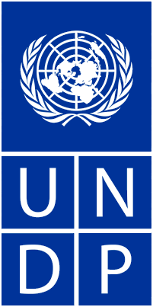
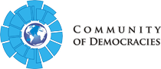
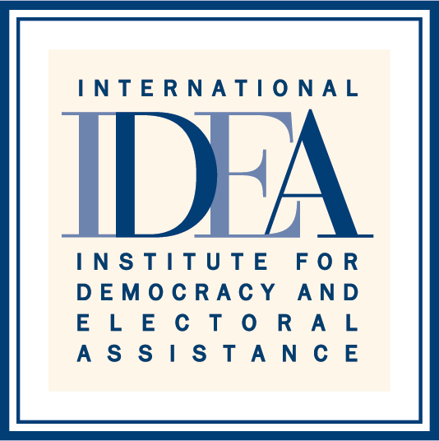

REGIONAL CONSULTATIONS ON GENDER EQUALITY AND
POLITICAL EMPOWERMENT OF WOMEN

CONCEPT NOTE

- What are the Regional Consultations on Gender Equality and Political Empowerment of Women?

The Regional Consultations on Gender Equality and Political Empowerment of Women are platforms designed to allow an open exchange among key stakeholders regarding the trends, challenges and opportunities in the implementation of international conventions, agreements and treaties, as well as specific actions to address the main issues related to the advancement of Gender Equality and the Political Participation of Women.

The Consultations will seek to identify the main instruments that are set in place by the regional organizations in support to their Member States and in compliance with their mandates, to address the issues related to the broader topic of this initiative. The Consultations will also highlight the challenges as perceived by the international, regional and sub-regional organizations, as well as by Member States and Civil Society Organizations (CSOs,) and will gather the best practices and experiences in the task of advancing Gender Equality. This initiative contributes to the implementation of Agenda 2030 and the advancement of its goal 5 in particular. It will also be instrumental in consolidating policy recommendations on how to better achieve and be more effective/efficient in the advancement of Gender Equality and Political Empowerment of Women.

The consultations will have a regional focus with the intention to emphasize on the needs and gaps of each particular region and allow the participation on relevant actors that would not be able to do so on a broader event. The regional focuses will be Africa, Asia-Pacific, Europe and the Americas.

- What is the objective of the Regional Consultations?

The objective of the Regional Consultations is to provide a space where representatives of the international, regional and sub-regional organizations, Member States, Civil Society Organizations (CSOs), women in politics and other relevant stakeholders can openly discuss trends, challenges and opportunities in advancing Gender Equality and the Political Empowerment of Women.

In these lines, the Consultations aim at gathering the experiences and best practices of the regional organizations, and bridge the knowledge gap on this particular issue, to formulate a set of straight-forward policy recommendations that will inform policy makers at the state and at the multilateral level to develop more effective policies and actions.

The results of the Regional Consultations will be captured in reports summarizing the discussions and including the final recommendations. The key components of the report will be integrated into a Policy Guidebook on Gender and Political Participation of Women to be developed with the input of the regional organizations that are part of the Inter-Regional Dialogue on Democracy (IRDD.)

- Why is the theme important?

Unequal opportunities and conditions for political participation and representation between men and women still exist worldwide. Women remain under represented from the structures of governance that determine political and legislative priorities as highlighted in the UNDP Guidebook to promote Women´s Political Participation. These facts are widely recognized and should be included in the public agenda, considering that equal participation is essential to the achievement of democracy.

Democracy is supposed to transform power relations between men and women in such a manner that gender equality is promoted in terms of inclusiveness, participation, representativeness and accountability of democratic processes and institutions. The universal principle of equality and non-discrimination between women and men forms one of the major global commitments in the pursuit of gender equality in democracy building.

All major global agreements and commitments for the past three decades have highlighted the need to acknowledge and address continued gender inequalities in all spheres of life. Inclusive and responsive political processes are prerequisites for equitable and sustainable development.

The low numbers of female participation continue despite decades of efforts by international and regional organizations, as well as by national governments to eliminate discrimination against women and promote the empowerment of women. The International Parliamentary Union (IPU) data show that in the world´s parliaments today, women hold 22 percent of the seats.

In 2005, women held 16 percent of seats and in 1995, 11 percent. Even if figures alone do not help us to understand the quality of the representation, they are nevertheless important in giving systematic evidence of women´s experiences and access to political institutions: these numbers capture the great progress that has been achieved in the last 20 years. Notwithstanding this, these numbers also consistently show evidence of the persisting gender imbalances and exclusion.

In order to understand and capture the quality of political participation and representation for both men and women, there is a need to assess the challenges and opportunities that exist in politics and policies determining participation and representation in democratic processes. Numbers do matter, but equally for men and for women, the accountability and the quality of their “democratic performance” is increasingly in need of transparency.

Today, as a recent UN Women Report highlights, the issue of political participation and representation of women has also been affected by the global economic crisis and the resulting public finance and austerity measures. These policies, which have caused unnecessary hardship and reinforced existing inequalities, are likely to have negative long-term social, economic and political consequences, and cause significant reversals in the enjoyment of human rights around the world.

In this light, it is only timely to focus on an alternative policy agenda to address the root causes of inequality, including looking at the intersectionality of multiple inequalities and processes of discrimination. In addition, it is fundamental that the efforts and the core instruments from the regional organizations, including conventions, resolutions, legal instruments and programmatic agendas move beyond the identification of the causes and impediments towards the achievement of gender equality, but to the design and systematic implementation of gender responsive measures/mechanisms to guarantee equality and prevent gender based discrimination.

Regional Organizations have developed mechanisms and instruments, as well as special initiatives to support gender equality. They have also developed action plans, work plans and strategies for equality that if fully implemented, would considerably advance women’s rights and bring their Member States closer to real gender equality. However, Regional organizations face a number of challenges that limit their capacity to promote and possibly enforce gender equality in their regions.

These challenges are not limited to the availability of resources, but they also arise from the scope of mandates, the political context and the political support and backing of Member States. It is particularly important that Member States increase their efforts in this field, including by reforming their constitutional and legal frameworks in order to promote gender equality and increase women’s political participation and representation but also by implementing effective monitoring and evaluation mechanisms to assess the progress. For this endeavor in particular, the importance of collecting and compiling high quality gender-disaggregated data cannot be sufficiently emphasized.

One main challenge that remains is the gap between the norm setting at the regional level and the implementation/enforcement at the national level. Agenda 2030 and its goal 5 in particular, give regional organizations yet another instrument for influencing the policies and practices of their Member States towards genuine reforms to achieve gender equality.

- How will the Regional Consultations work?

The Regional Consultations will be organized jointly by the implementing parties and will provide a forum to exchange experiences and good practices among the relevant stakeholders. The regional consultations will be held back-to-back with the following international events (tentative):

- World Forum for Democracy – 7-9 November 2016 – organized by the Council of Europe
- Bali Democracy Forum – 8-9 December 2016 – Organized by the MFA of Indonesia
- 46th General Assembly of the Organization of American States (OAS) – First week of June 2017 in Mexico
- AU Summit – January 2017

The Regional Consultations will have a workshop format, to be structure based on the relevant guiding questions to be provided by the organizers (See next section). These questions are not exhaustive, but will constitute the core of the exchange.

The consultations will: (1) look into the legal instruments and mechanism to promote gender equality and contribute to increased women political participation, (2) lead to formulation of the policy recommendations on gender mainstreaming, and (3) explore how the UN and CSO can work together to advance gender equality and women political participation.

The workshop will have a moderator from one of the organizers, and will have the presence of high-level representatives of the respective regional organization (depending on the region where the consultation is taking place,) Member States and others relevant to the topic at hand, which will be invited to provide opening remarks.

Once the opening remarks are presented, the moderator will be in-charge of providing an introduction to the topic to be discussed and a general explanation on the scope of the questions, and will open the floor for the discussion.

A report summarizing the discussions and including the final recommendations will be drafted after each Regional Consultation, and made public in an electronic copy. The key components of the report will be integrated into the Policy Guidebook on Gender and Political Participation of Women.

- What are the guiding questions for the Regional Consultations?

The following questions were designed as a guide for the participants and the moderator(s) of the Consultations, but are in no way intended to limit the discussion. They are presented below considering the elements that are key for the purpose of the consultation, including the normative and legal framework, the types of intervention, the impact and the partnership components:
Normative and legal framework
- What legal and policy instruments are available in the region?
- Which institutions and organs of the regional organizations are responsible for coordinating and mainstreaming work on gender equality and the political empowerment of women?
- What mechanisms can better assess the implementation of instruments developed/ adopted?

Types of interventions at the regional or national levels:

- What activities have regional organizations engaged in to promote equality among men and women?
- How can we connect the diverse mechanisms that monitor global and regional commitments to ensure that states strives towards the goal of sustainability regarding gender equality and political empowerment of women?
- How could the regional organizations contribute to monitoring global commitments, such as Beijing/WPS/CEDAW?

Impacts

- At the global and regional levels, what mechanisms can efficiently monitor and effectively evaluate the impact of the actions taken to advance gender equality and the political empowerment of women?
- Based on the latest experience, what has been the effectiveness of the instruments and actions in place, and how can global and regional organizations improved effectiveness in the future?
- What tools could be used to build on regional experience in order to assess compliance with global commitments?

Partnership

- What can be done to facilitate the transfer of experience key stakeholders, including national authorities, while taking into account the numerous initiatives developed by non-state actors (private sector, NGOs, research)?

- Who will participate?

The Regional Consultations will involve representatives from the international, regional and sub-regional organizations, political decision-makers, representatives from Civil Society Organizations working on issues related to gender equality and political empowerment of women and other social actors directly involved with the theme of the consultation.

The purpose of having a consultation per region is to allow the relevant actors to participate and be able to contribute to the discussion, and by holding the events on the sideline of high-level events organized by regional organizations, it is expected that more participants get involved in the exchange and provide input on how to better address these issues.

- Who is behind the Regional Consultations?

The Regional Consultations are co-organized by the Communities of Democracies, International IDEA and the United Nations Development Programme (UNDP).

The International Institute for Democracy and Electoral Assistance (IDEA) / Inter-Regional Dialogue on Democracy (IRDD)

Since its inception in 1995, International IDEA has made significant contributions to the body of available knowledge and applicable policy options for promoting democratic participation and representation of women in decision-making processes. Through its global and regional programmes, IDEA supports political reform processes, awareness raising and capacity building on institutionalizing gender equality and women’s empowerment in electoral and constitution-building processes, and within political parties.

The Inter-Regional Dialogue on Democracy (IRDD) was launched in April 2011 by seven Regional Organizations and International IDEA at the headquarters of the Organization of American States (OAS). Its primary objective is to offer and facilitate a platform for regional organizations to exchange as peers knowledge and experiences in the application of democratic principles.

To date, eight regional organizations are participating in the IRDD and these include the African Union (AU), the Association of Southeast Asian Nations (ASEAN), the Council of Europe (CoE), the European Union (EU), the League of Arab States (LAS), the OAS, the South Asian Association for Regional Cooperation (SAARC) and the Pacific Islands Forum (PIF). International IDEA acts as the facilitator of the IRDD and functions as its dedicated secretariat through the Inter-Regional Democracy Resource Centre.

United Nations Development Programme (UNDP)

UNDP works in nearly 170 countries and territories, helping to achieve the eradication of poverty, and the reduction of inequalities and exclusion. We help countries to develop policies, leadership skills, partnering abilities, institutional capabilities and build resilience in order to sustain development results. UNDP is working to strengthen new frameworks for development through integrated approach to supporting inclusive political processes in supporting and strengthening the capacities of political processes and institutions in order to improve citizen participation, voice and accountability.

The advancement of women’s equal participation and decision-making in political processes and institutions is one of the key priorities for UNDP across a variety of development contexts including stable, conflict/post conflict and transitional settings.

Community of Democracies (CoD)

The Community of Democracies (CoD) is an international organization that promotes and protects the democratic values enshrined in the groundbreaking Warsaw Declaration that 106 countries signed in 2000. The CoD drives the global democracy agenda through common action of governments, civil society, parliamentarians and the private sector. Established in 2000, the CoD brings together governments, civil society and the private sector in the pursuit of the common goal of supporting democratic rules and strengthening democratic norms and institutions around the world.

The Community of Democracies, from the moment of its inception in 2000, strongly supports activities and projects dedicated to women’s empowerment and gender equality. The Warsaw Declaration clearly states, “Informed participation by all elements of society, men and women, in a country's economic and political life, including by persons belonging to minority groups, is fundamental to a vibrant and durable democracy”. That is to say, there is no “vibrant and durable democracy” in a country, if women and men are not equal parts of the society they form.

