
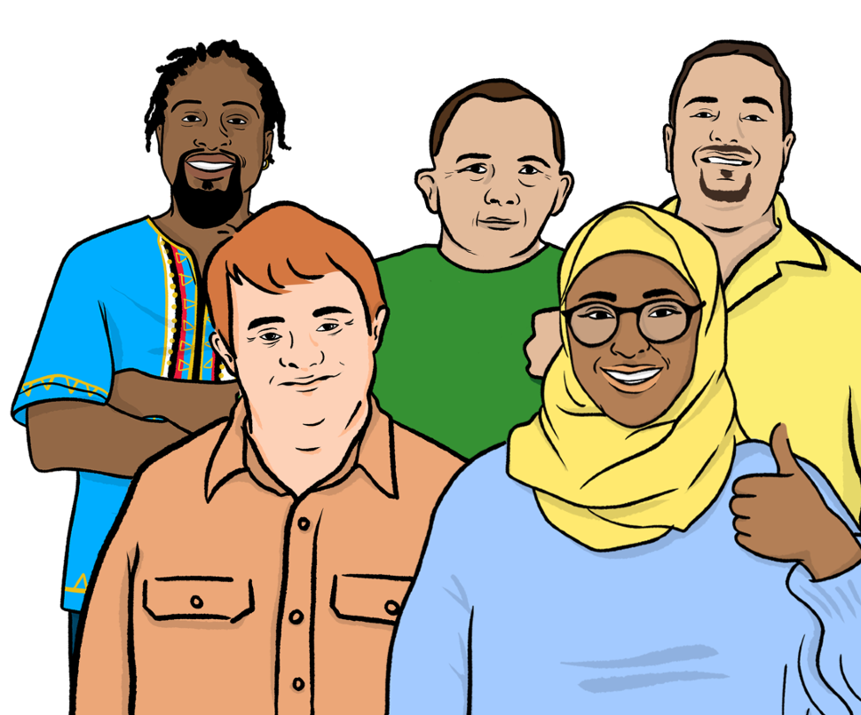


Local democracy

Easy Read

Easy Read
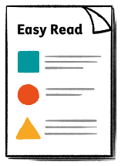
This is an Easy Read version of some information. It may not include all of the information but it will tell you about the important parts.

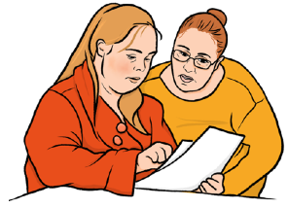
This Easy Read booklet uses easier words and pictures. Some people may still want help to read it.


Some words are in bold - this means the writing is thicker and darker.
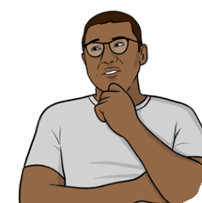
These are important words in the booklet.

This word
means….

Sometimes if a bold word is hard to understand, we will explain what it means.



Blue and underlined words show links to websites and email addresses. You can click on these links on a computer.

links

What is in this booklet
What is local democracy? 4
Good and bad things 5
Including local democracy in a constitution 6
What is right for different countries 17
Protecting local democracy 20
Other ways of working 23
Questions to think about 25
Find out more 28

What is local democracy?

This guide is from the International Institute for Democracy and Electoral Assistance (IDEA). It is about local democracy.

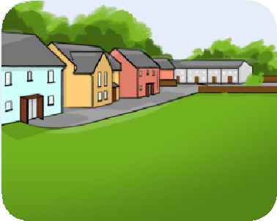
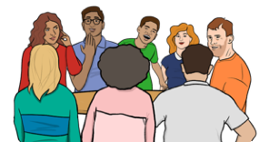
Local democracy means giving power and responsibility to smaller areas, like towns, cities and villages.


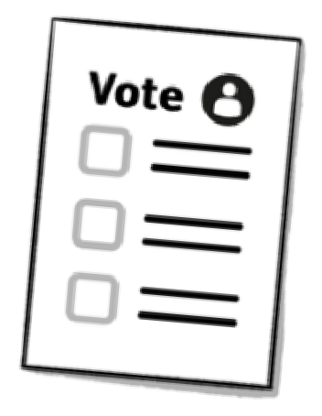
If you vote for your local council or mayor, this is local democracy.

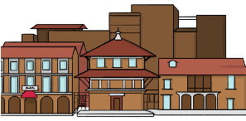
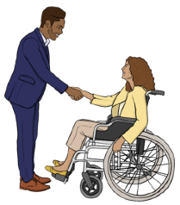
Local democracy can help people to take part in their local areas, make services better and make local communities stronger.


This guide explains how countries can write rules to support
Rules
local democracy.


Good and bad things

Local democracy can be good and bad.

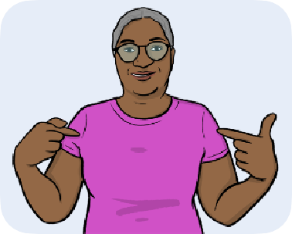
Local democracy means that local leaders can make choices that are right for the people who live there.


It can help people to get involved and make things better for their area.
Better


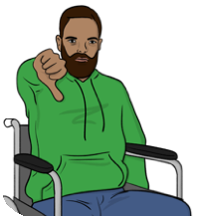
But, it can be a problem if local leaders get too much power.

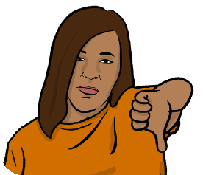
If this happens, services can become bad and unfair.

Including local democracy in a constitution

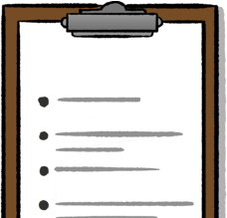
A constitution is a list of rules for how a country is run.

Constitution


Governments cannot easily change constitutions.

Change

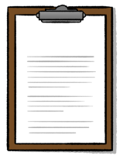

Some countries have constitutions with rules about local democracy.

Rules


They might say how local democracy should work and what local leaders can do.



It is good to include local democracy in constitutions.

Constitution


The rules about local democracy will not often change if they are written in the constitution.

Rules


When people write about local democracy in constitutions, they have to think about 3 things:

- What people want, what is fair and what it is possible to do.


- Making sure that local leaders are fair and listen to people.

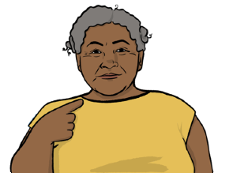
- Giving local areas the chance to make choices for themselves.

Choosing who is in charge
In most places, there is a local
Laws
council. This council:


  - Makes local laws.
  - Chooses how to spend money on local services.

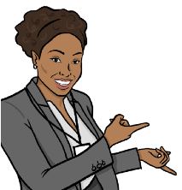
In some countries, the constitution explains how to choose a local council.

Many places also have a mayor. This is a local leader.


The mayor might be chosen by the council, or voted for by the people.

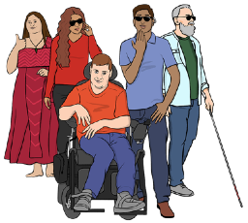
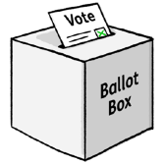
Some constitutions have rules about how often local elections should happen.

Local elections are where everyone in a local area votes on who should be their leader or council members.

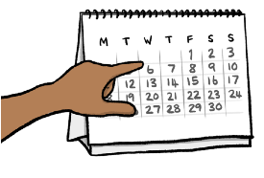
For example, the law in Ireland says local elections must happen every five years.


Some councils also have someone called an administrator.

They help to make sure that services follow what the council says.

The constitution of a country might say:
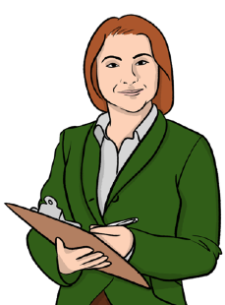


  - How mayors and administrators should be chosen.

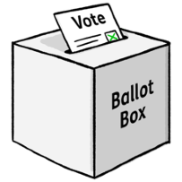
  - How local elections for mayors should happen.

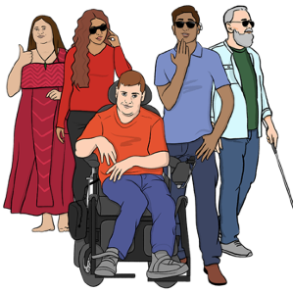
How many women or people from marginalized groups there should be on the council.
•

Marginalized groups are people who are not always treated fairly, and find it hard to be heard.


Giving power to local areas

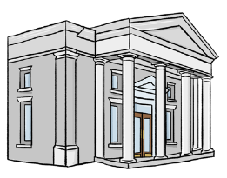
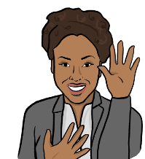
Some countries say that the national government can decide how much power local areas can have.

The national government is in charge of the whole country.



Change
In some countries, the national government can change the power of local areas if they think it is right for the country.

Constitution
But other countries have a constitution that says how much power a local area has.



Safe
This can help to protect local areas, if the government is making choices that are not right for them.


Some countries allow local areas to have more power, but only if the government agrees.


In some places, local areas can make their own rules, as long as they follow the country’s law.

The law

This means that they do not need to ask the government before they make these rules.
Can we do this?



But the government can still step in if they think they need to.


Sharing power

Rule

One idea is to put a rule called the principle of subsidiarity in the constitution.

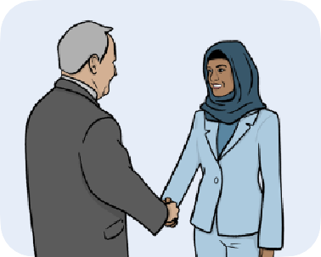
This is a way to share power between local areas and governments.



It says that a country’s government should not get involved in the work of local governments.

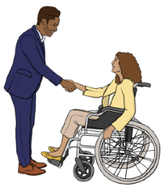
Instead, they should help the local government when they need it.


The principle of subsidiarity can be part of the law. Or countries can just use it as a guide.
The law

Money




In some countries, the national government chooses how much power local areas have over money.
Budget

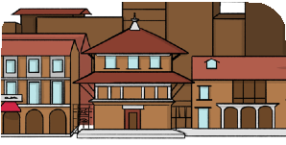
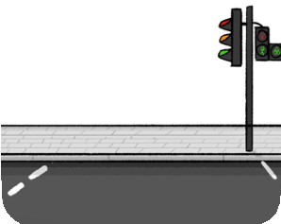
They might tell them that they need to spend money on certain services, like roads or housing.


This can mean that local areas cannot decide how to spend money without asking the government first.
We want to spend money on…

Some countries have constitutions that say how much money should go to local areas.

Constitution

Special rules for some local areas



Sometimes, one local area might have different rules from other local areas, based on what they need.
Rules
Rules

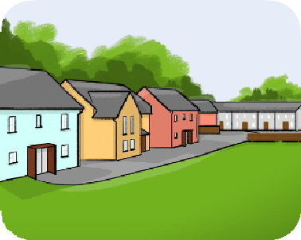

These rules depend on what is right for that local area.

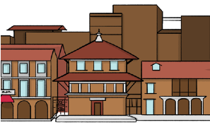

For example, in Kenya, there are extra rules about local democracy in the biggest cities.

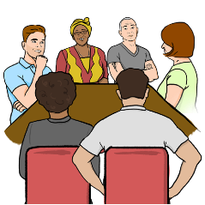
Special organisations

Some places have special organisations that are in charge of a local service.

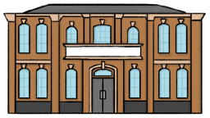

For example, some places have school boards. These are groups that are in charge of schools for that local area.
School

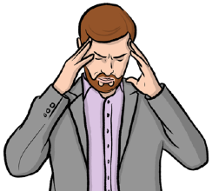
But having too many special groups can cause problems.

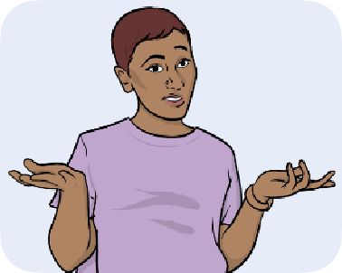
It can be hard to know who is in charge.


It can also cost a lot of money.

What is right for different countries

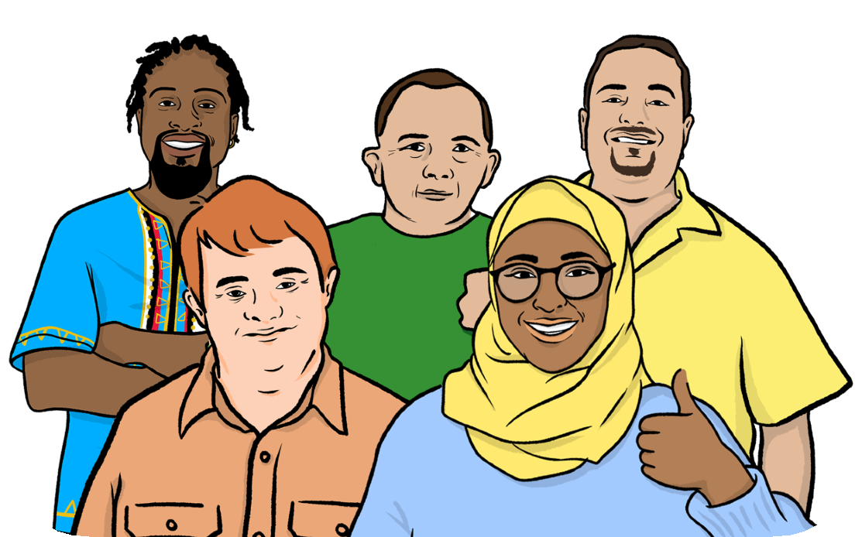
Different countries need different types of local democracy.

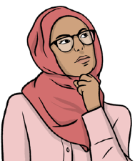
If a country is writing a constitution, it is important to think about what is important for them.



When countries think about including local democracy in their constitution, they should think about:

- If the country already has some local democracy, like councils, or if
they are making new ones.


- How much people and the government trust each other.

They should also think about:
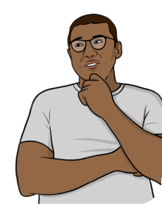
- How important local democracy is to the country.


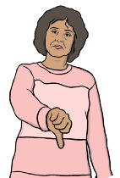
- If people in the country do not agree on how much power local
areas should have.

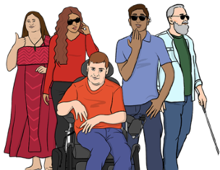
- How much different groups, like marginalized groups, want to have a
say in local democracy.



Better
- If people want more local democracy because local
government can give people better services.

They should also think about:


Safe
- If there are safety issues, like war or violence, in some parts of the
country.


- If the country is a federal country.
Federal countries share power between the government and local areas, like states or provinces.

Rules
- What rules around the world say about local democracy.

Protecting local democracy



Constitutions can have rules that protect local democracy from people who want power for themselves.


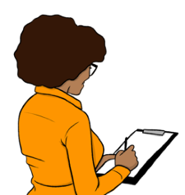
Checking that leaders follow the rules

There should be organizations to check that local leaders do not break the rules.

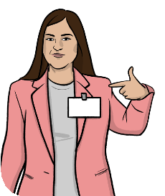

The government should not be in charge of these organizations.

The constitution can have rules about how these organizations work.

Constitution



Getting rid of bad leaders

There should be a way to get rid of bad leaders.

This might be:

- Giving everyone on the council a way to vote them out.

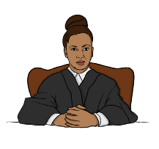
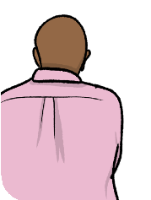
- Taking them to court for a crime.

- Giving everyone in the local area the chance to vote them out.

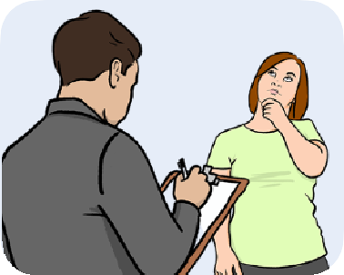
Asking the public

In some countries, local leaders can ask the public to vote on local issues.

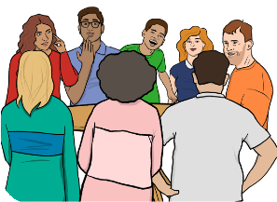
In other countries, local councils invite people to come to meetings and talk about things that affect them.

The national government

Sometimes, the national government might need to take over from local leaders.

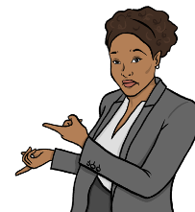
This might be for safety reasons, or if local leaders are not doing a good job. But, this should not happen too much.

Safe



Rules
Some countries have rules about when the government can take over from local leaders.

Other ways of working

In some countries, people do not choose local leaders in elections.

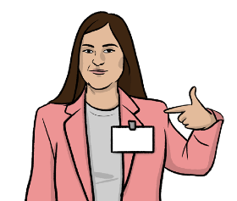
The government picks them instead.

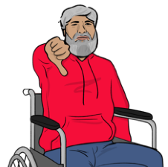
This is not as good as having elections.

But sometimes it might not be safe to have elections.

Safe


If an area uses leaders that the government has picked, there could be rules to make sure that they are fair to everybody.
Rules

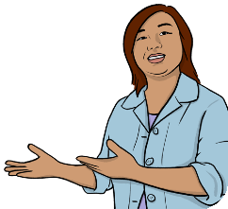
In other places, there are very old rules about who the local leaders are.
Rules

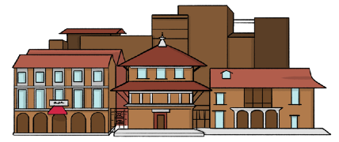
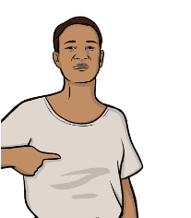
People like tribal chiefs might be in charge of a village.

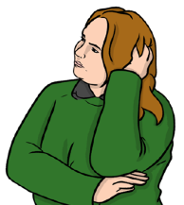
Some countries have laws that say what these leaders should and should not do.
Laws

Questions to think about

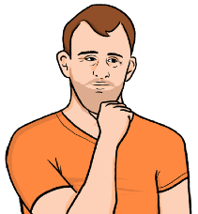
Here are some questions to think about:

- What is the point of local democracy? Can it make choices, or does it just do what the government says?


- How much money does the country have? Can they pay for local democracy?

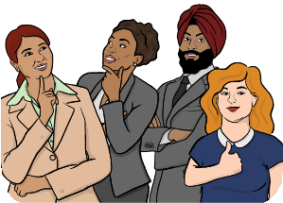
- Does the country have enough people who can work for local councils?

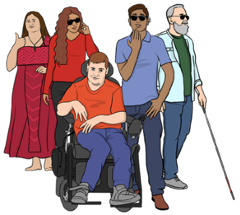
- Are there marginalized groups who need to be included?


- Is there already some local democracy?

- Do all parts of the country want more local power? Are there some places that need special rules?


- How can we make sure that local leaders listen to everybody?


- How can we make sure that we have good local leaders?

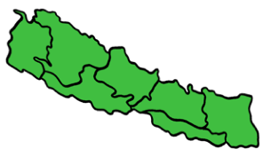
- How should we split a country into local areas?

Here are some more questions to think about:
Budget


- How can we make sure that local leaders have enough money to spend on public services?


- How do political parties affect how local democracy works?

Political parties are organisations that work together to run in elections.

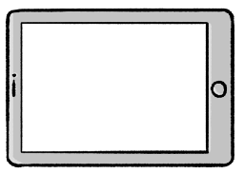
Find out more

You can look at our website here: www.idea.int


You can contact us by:
  - Post:
International Institute for
Democracy and Electoral Assistance (International IDEA)
Strömsborg SE-103 34

Stockholm Sweden

  - Phone: +46 8 698 37 00
@

  - Email: publications@idea.int

This Easy Read booklet was produced by easy-read-online.co.uk
The booklet includes images licensed from Photosymbols & Shutterstock.

